**JAVASCRIPT**

* Javascript statements will end in a semicolon(;)
  + Javascript statement examples:
    - Alert(“”);
      * Web page alerts user, dialog box
    - Console.log(“”);
      * Console will respond with the same string
    - Document.write(“”);
      * Console will open new page with same string
    - <https://teamtreehouse.com/workspaces/42176396>
  + JavaScript engine: a program (or interpreter) built into the browser that executed JavaScript code
  + Linking js file to an html file
    - <script src=”js/script.js”></script>
  + Variables: <https://developer.mozilla.org/en-US/docs/Web/JavaScript/Reference/Statements/var>
    - Naming Variables
      * Words you can’t used because they are reserved word <https://developer.mozilla.org/en-US/docs/Web/JavaScript/Reference/Lexical_grammar#keywords>
      * Variable names can begin with $ or _
        + <https://www.w3schools.com/js/js_variables.asp>
    - Addition assignment
      * <https://developer.mozilla.org/en-US/docs/Web/JavaScript/Reference/Operators/Addition_assignment>
      * var a = 2;

var b = 5;

console.log(a += b);

* + - using (let) & (const) instead of (var)
      * <https://developer.mozilla.org/en-US/docs/Web/JavaScript/Reference/Statements/let>
      * <https://developer.mozilla.org/en-US/docs/Web/JavaScript/Reference/Statements/const>
        + Cannot change or manipulate the value by reassignment and not able to redeclare a constant
  + Strings
    - <https://developer.mozilla.org/en-US/docs/Web/JavaScript/Guide/Text_formatting#strings>
      * Single or double quotes instruct the javascript engine that it should treat the contents inside as a regular set of characters
    - String: length
      * <https://developer.mozilla.org/en-US/docs/Web/JavaScript/Reference/Global_Objects/String/length>
        + The number of characters inside a string

console.log(nameOfVariable.length);

prints the amt of characters in thr javascript engine

* + - Strings are objects and you can access properties of an object using a (.)
    - Combining strings:
      * <https://developer.mozilla.org/en-US/docs/Learn/JavaScript/First_steps/Strings#concatenating_strings>
        + Const name = prompt(“what is your name?”);

Const message = “hello ” + name;

Console.log(message);

* + - * + let message = “hello”;

message = message + “nice to see you”;

message += “nice to see you”;

* + - Template literals:
      * <https://developer.mozilla.org/en-US/docs/Web/JavaScript/Reference/Template_literals>
        + `` = “” ‘’
        + String interpolation

<https://developer.mozilla.org/en-US/docs/Web/JavaScript/Reference/Template_literals#string_interpolation>

Const name = prompt(“what is your name?”);

Const message = `Hello, ${name}. It’s ${2 * 3} o’clock.`;

* + Methods
    - Methods, the () let the java engine know this is a method
      * console.log(nameOfVariable.toUpperCase() );
        + Transforms all of the characters to upper case in a string
      * console.log(nameOfVariable.toLowerCase() );
        + Transforms all of the characters to lower case in a string
      * Prompt();
        + <https://developer.mozilla.org/en-US/docs/Web/API/Window/prompt>
        + const varName = prompt(“”);
  + Query Selectors
    - <https://developer.mozilla.org/en-US/docs/Web/API/Document/querySelector>
    - querySelector(tag name, class or ID as a string);
      * document.querySelector(‘main’).innerHTML = varName;
        + will cause content to show up on HTML page
  + Conditional Statements
    - <https://developer.mozilla.org/en-US/docs/Web/JavaScript/Reference/Statements/if...else>
    - <https://developer.mozilla.org/en-US/docs/Learn/JavaScript/Building_blocks/conditionals>

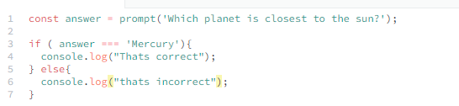

* Else-if statements
  + <https://developer.mozilla.org/en-US/docs/Web/JavaScript/Reference/Statements/if...else#using_else_if>

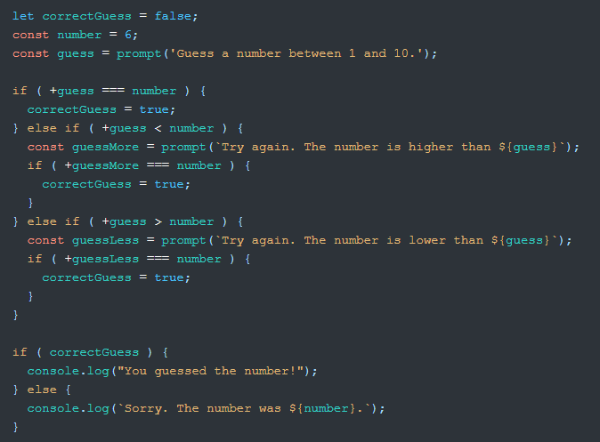

* Comparison Operators
  + <https://developer.mozilla.org/en-US/docs/Web/JavaScript/Reference/Operators>
  + equality operator (==)
    - tests if two values are the same, makes some allowances of the values
      * ( ‘3’ == 3 ) true
  + strict equality operator (===)
    - compares the type as well as the value
      * ( ‘3’ === 3 ) false
  + Not equal (!=)
  + Strict inequality (!==)
* Boolean
  + Quotes should not go around Boolean values

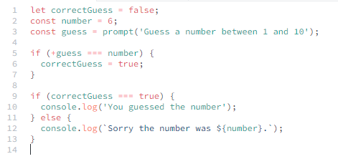

* (+) if front of varName turns the string into a num if it isn’t already
  + <https://developer.mozilla.org/en-US/docs/Web/JavaScript/Reference/Operators/Unary_plus>
* && operator
  + <https://developer.mozilla.org/en-US/docs/Web/JavaScript/Reference/Operators/Logical_AND>
* || OR operator
  + <https://developer.mozilla.org/en-US/docs/Web/JavaScript/Reference/Operators/Logical_OR>

*JavaScript Numbers*

* <https://developer.mozilla.org/en-US/docs/Learn/JavaScript/First_steps/Math#types_of_numbers>
  + Scientific notation
    - 9e-6 // same as .000009
    - 9e+6 // same as 9,000,000
  + Integer
    - Whole numbers that can be positive or negative
  + Floating point numbers
    - Numbers with a decimal
* Math operators

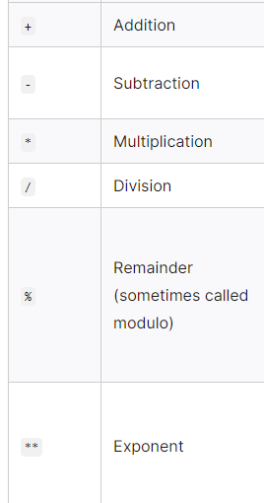

* + <https://developer.mozilla.org/en-US/docs/Learn/JavaScript/First_steps/Math>
  + typeof
    - returns a string indicating the type of the operand’s value

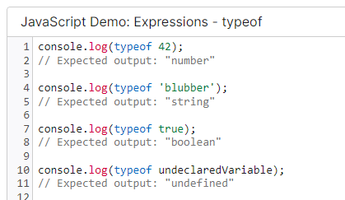

* converting a string to a integer number
  + parseInt()
* converting a string to a float point
  + parseFloat()
* unary plus(+) works with integers & float point numbers
* math.
  + <https://developer.mozilla.org/en-US/docs/Web/JavaScript/Reference/Global_Objects/Math>
  + ex. 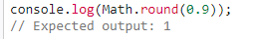
* random numbers
  + <https://developer.mozilla.org/en-US/docs/Web/JavaScript/Reference/Global_Objects/Math/random>
  + Math.random();
  + Math.floor();
    - Rounds a number down to the closest integer
  + Math.ceil();
    - Rounds a number up to the closest integer

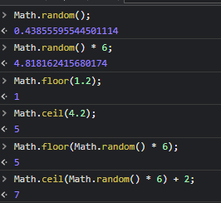

* NaN = not-a-number

FUNCTIONS

* <https://developer.mozilla.org/en-US/docs/Web/JavaScript/Guide/Functions>

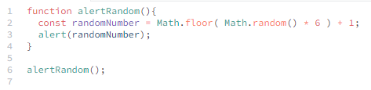

* + - Return ;
      * When a return statement runs, it causes the javascript engine to exit the function immediately. Return state should be the last line of code you want to run in a function block
      * Return statements can only return 1 value
* Parameters
  + <https://developer.mozilla.org/en-US/docs/Glossary/Parameter>
  + Go inside the parantheses of a function name
    - Function goGetCoffee(drink){}
  + When you pass information to a function, its called passing an argument
  + Parameters are like variables that you define in the function
* **Hoisting** refers to the process whereby the interpreter appears to move the declaration of functions, variables or classes to the top of their scope, prior to execution of the code
* Putting the word function first makes this a function declaration

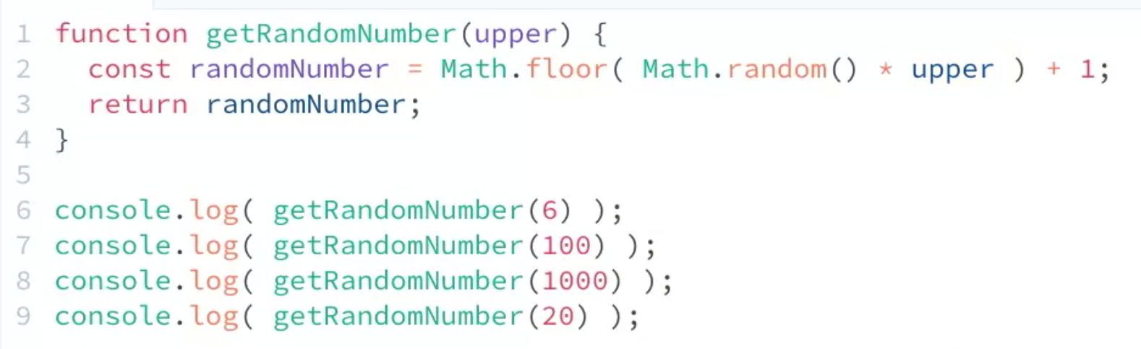

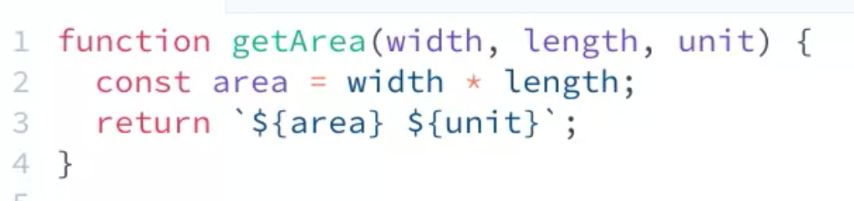

* Scope
  + <https://developer.mozilla.org/en-US/docs/Glossary/Scope>
  + scope is the context in which values are visible or can be referenced
  + one of the ways java uses to protect variables from overriding each other
  + different kinds of scopes
    - function scope
      * scope inside a function
    - global scope
      * scopes located outside of the functions
      * function scopes can override global scopes
        + use const for variables because they cant be reassigned, but this is not a recommended method

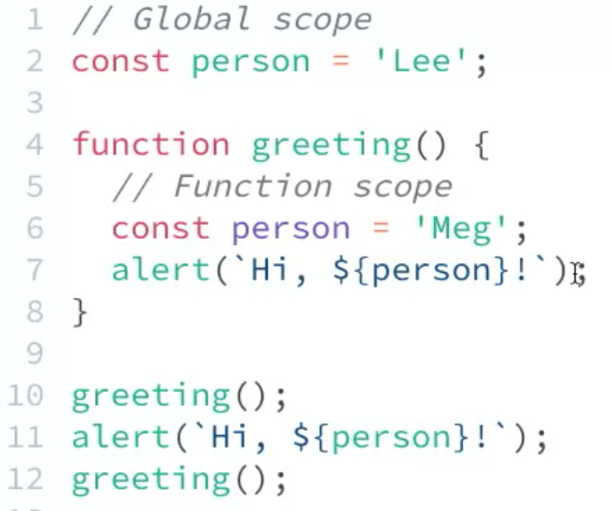

* A function expression lets you assign a function to a variable
  + They are not hoisted by the javascript engine

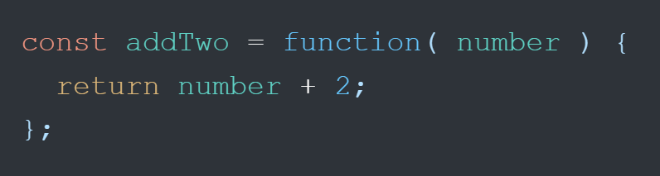

* Arrow function: =>
  + They are not hoisted by the javascript engine

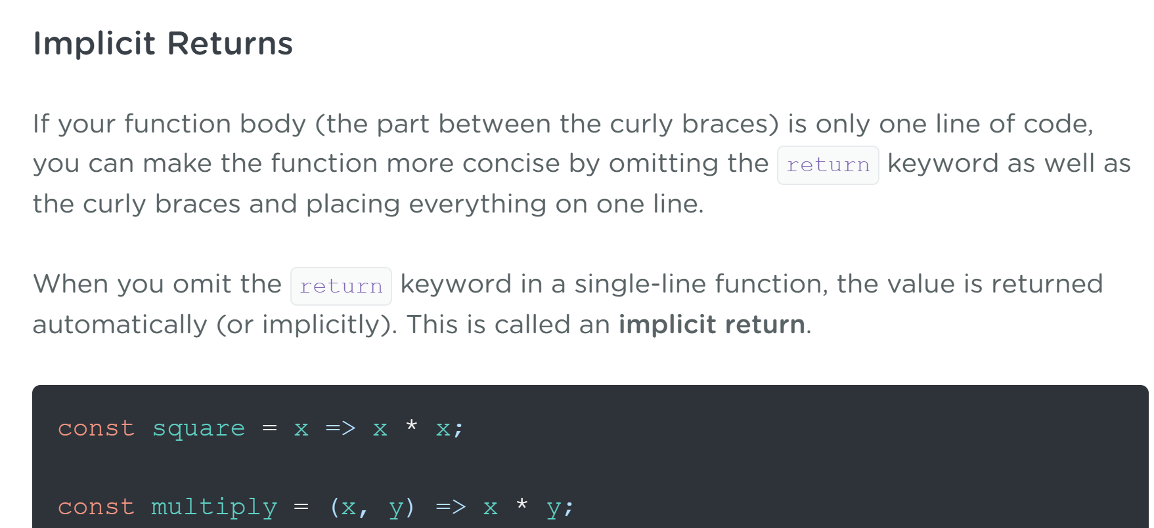

EXCERSIZES

1. declaring & printing onto HTML page using JavaScript

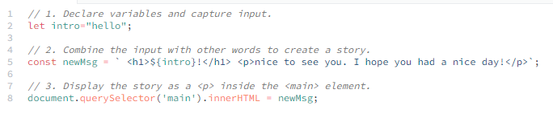

1. writing first javascript program, that keeps score of your right answers

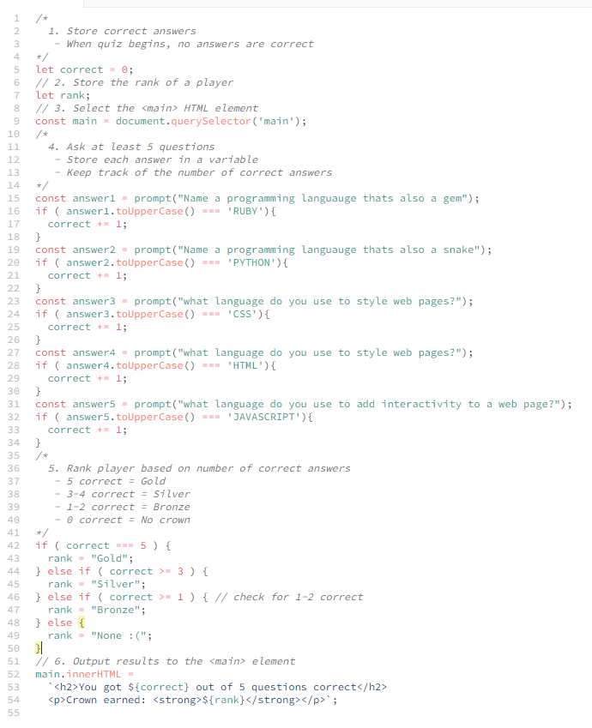

1. program that takes an input and multiplies it by a random number and prints the result in the console

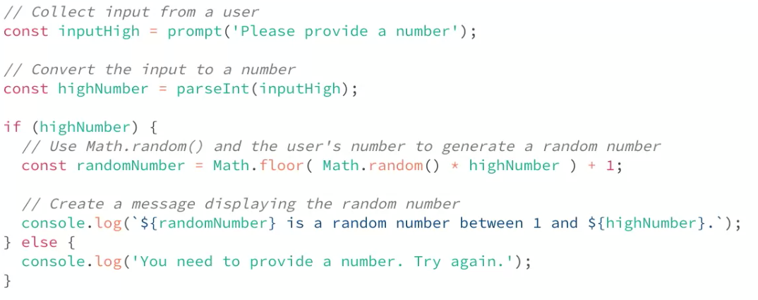

1. program that takes two random numbers and returns a number between them

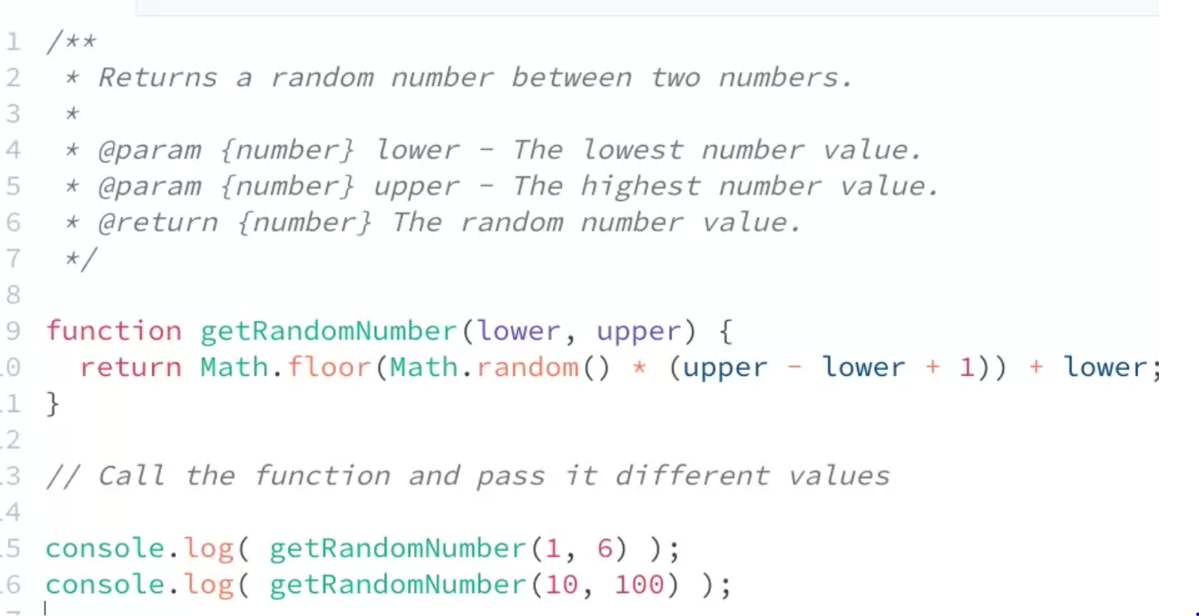

**JAVASCRIPT LOOPS**

* A loop is a way to repeat the same set of actions a certain number of times or until a specific condition is true
* Increment operator (++), adds 1
  + Counter += 1; = counter++;
* Decrement operator (--), subtracts 1
  + Counter--;
* Avoiding Infinite loops:
  + - <https://www.digitalocean.com/community/tutorials/using-while-loops-and-do-while-loops-in-javascript>
  + (break) lets you exit a loop
  + Have a condition that exits a loop once condition is met
* While Loop: creates a loop that executes a specified statement as long as the test condition evaluates to true. The condition is evaluated before executing the statement.
  + <https://developer.mozilla.org/en-US/docs/Web/JavaScript/Reference/Statements/while>

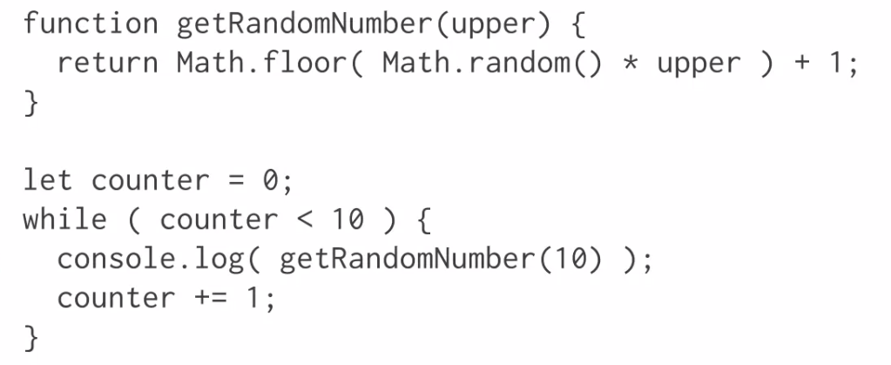

* Do While Loop:  creates a loop that executes a specified statement until the test condition evaluates to false. The condition is evaluated after executing the statement, resulting in the specified statement executing at least once. Condition is tested after the code block.
  + <https://developer.mozilla.org/en-US/docs/Web/JavaScript/Reference/Statements/do...while>

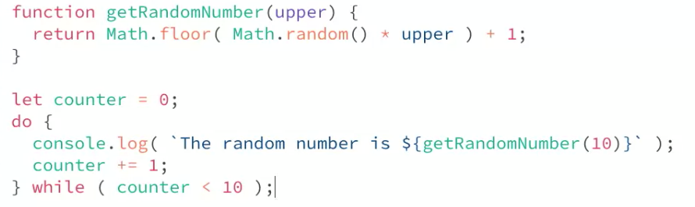

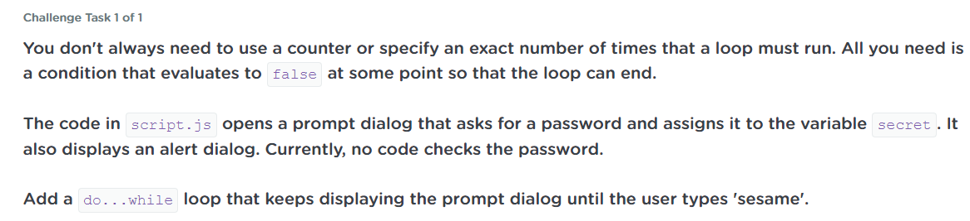

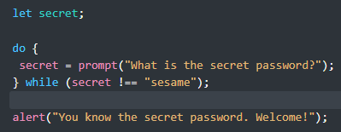

* For Loop: creates a loop that consists of three optional expressions, enclosed in parentheses and separated by semicolons, followed by a statement (usually a [block statement](https://developer.mozilla.org/en-US/docs/Web/JavaScript/Reference/Statements/block)) to be executed in the loop.
  + <https://developer.mozilla.org/en-US/docs/Web/JavaScript/Reference/Statements/for>
  + condition 1 is tested before loop begins
  + condition 2 is tested before loop begins, this is the condition that prevents the loop from being an infinite loop
  + condition 3 is a a counter that keeps track of the loop iterations in a physical form

Displays 10 random numbers in the console:

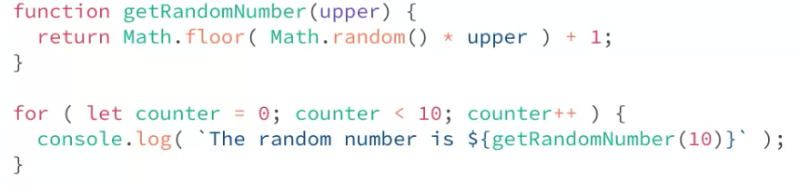

Displays numbers from 5-100 counting by 5’s on the web page:

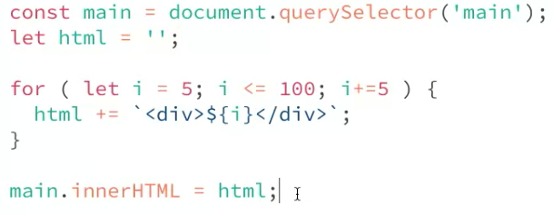

Gives user 5 times to guess the secret word, but doesn’t exit once the word is guessed, the loop continues to run until user has guessed 5 times

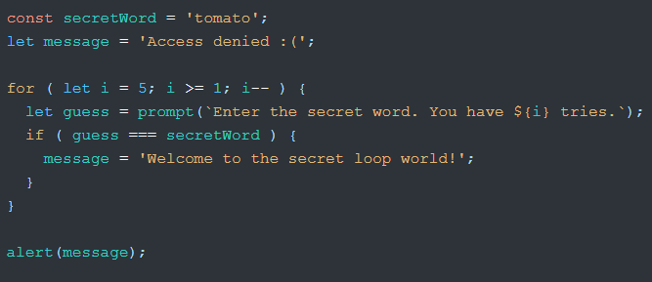

This loop gives the user 5 guesses but stops once the secret word is guessed

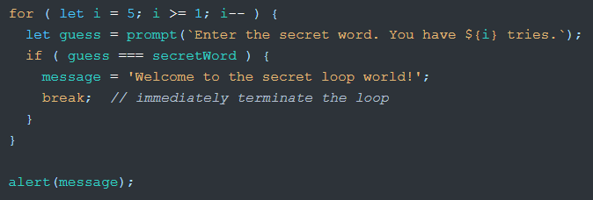

This loop asks a user if they want to continue until launch, if user types “y” in dialog box then the program continues until the test condition is no longer true, then it exits the program or “liftoff”, if the user types “n” then the program exits or “abort launch”

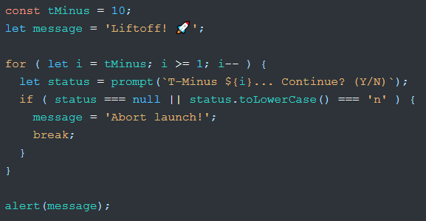

This loop displays number 1-10 on the webpage with different colors as the background, that random numbers determine the RGB of the background

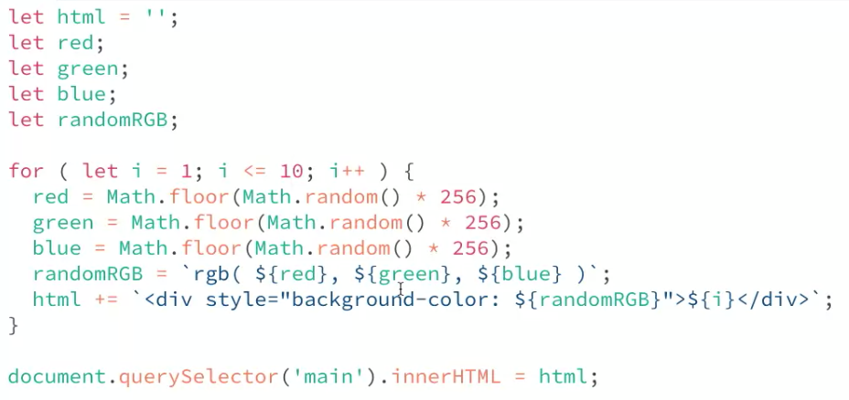

Same loop, refactored

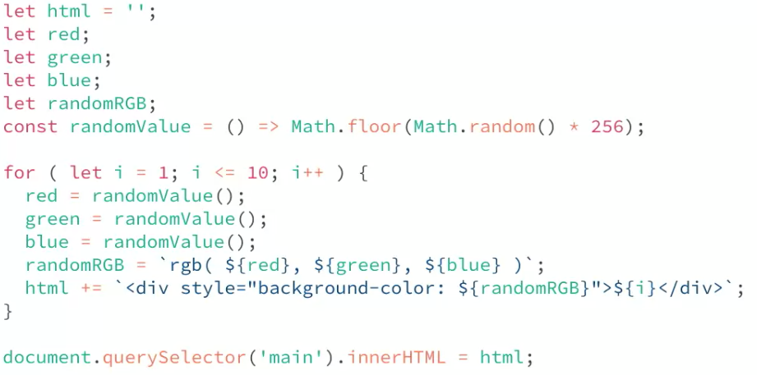

Refactored again

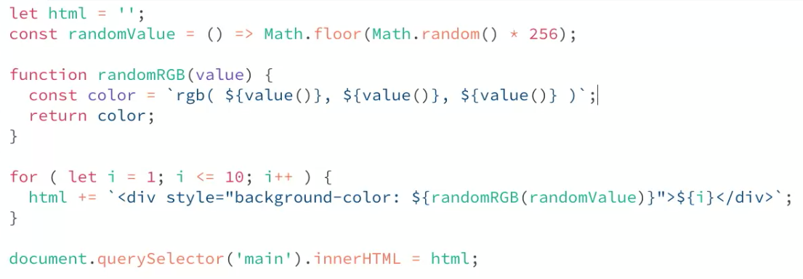

**JAVASCRIPT ARRAYS**

* <https://developer.mozilla.org/en-US/docs/Learn/JavaScript/First_steps/Arrays>
* a neat way of storing a list of data items under a single variable name.
  + let varName = []; can put strings or numbers inside an array
  + to find an item in an array, declare the variable name and find it using its place number or index. The array starts at 0

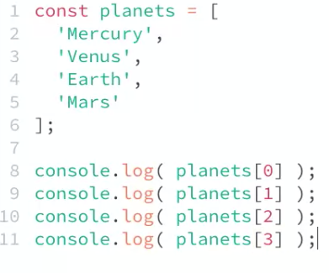

* properties you can use with arrays
  + .length; shows how many values are being stored in an array
  + .push(); places one or more values at the end of an existing array
  + .unshift(); places one or more values at the beginning of an array
  + .pop(); removes the last item from the end of an array, doesn’t take an argument
  + .shift(); removes the first item from the end of an array, doesn’t take an argument
  + .join() returns the contents of an array as one string separated by commas
    - Usually pass the parameter a string that you want the elements to be separated by, default is a comma
  + .includes() determine whether an array includes a certain value among its entries and returns either true or false
    - Parameter passed is the value you are searching for
  + .indexOf(); to return the index, position of a certain value inside an array
    - Parameter passed is the value of whos index you are looking for. When a value is not in an array, this returns -1 because it is not in the array
  + Math.max(varName);
  + Math.min(varName);
  + Spread operator (…)
    - Spread creates a copy of the original array, and properties do not affect it unless explicitly called

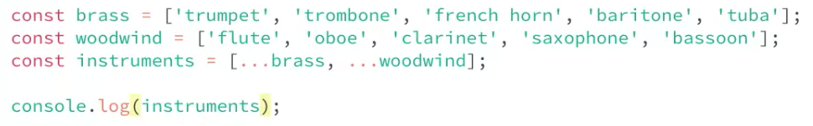

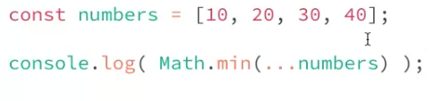

* Using a for loop to iterate through an array

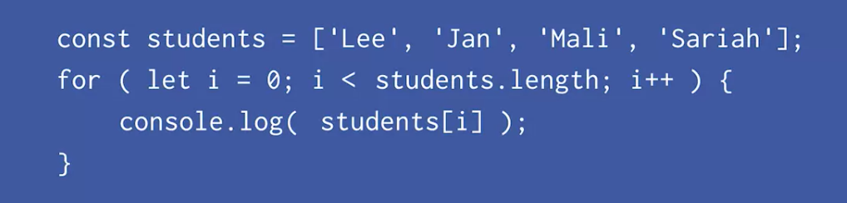

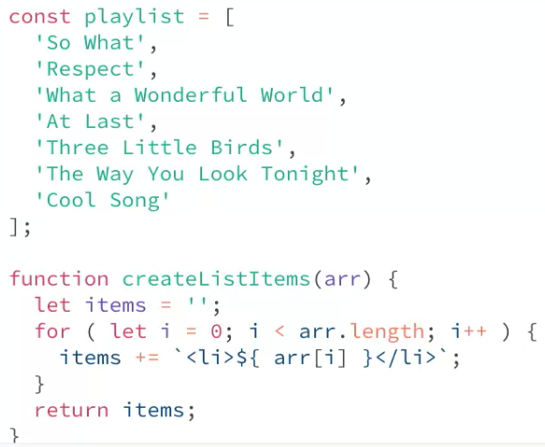

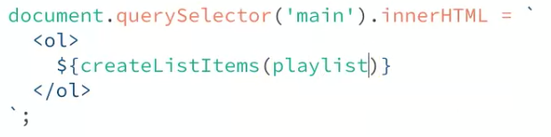

Prompts user to ask for a a grocery in stock and displays an answer on the web page

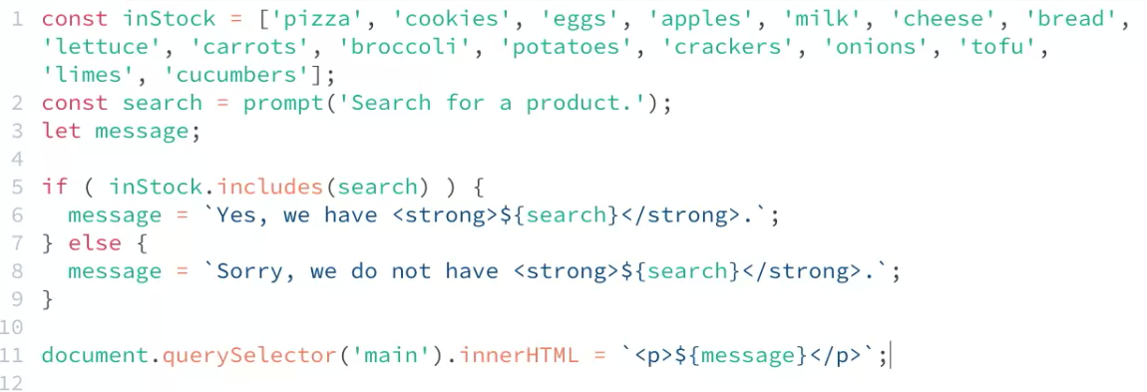

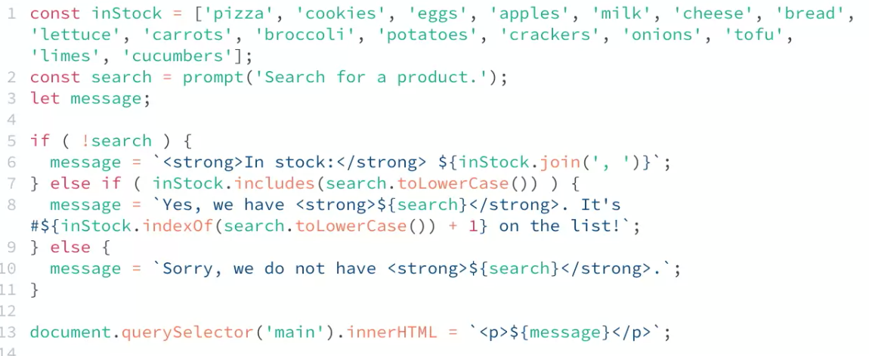

* multidimensional arrays
  + <https://developer.mozilla.org/en-US/docs/Web/JavaScript/Reference/Global_Objects/Array#creating_a_two-dimensional_array>

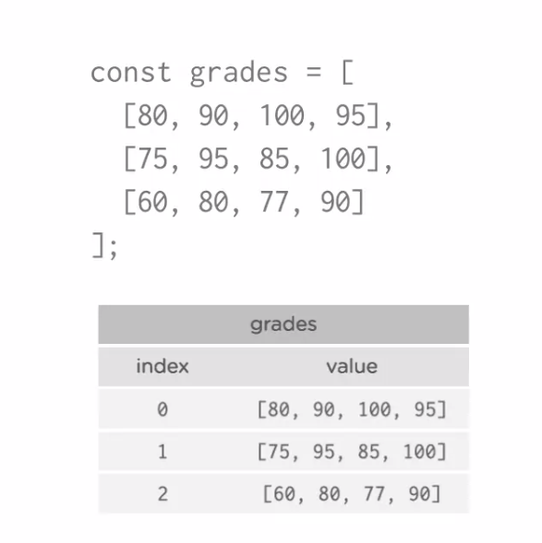 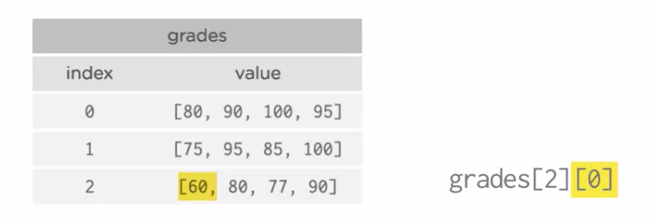

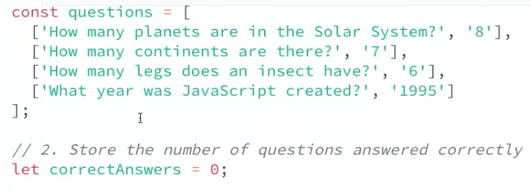

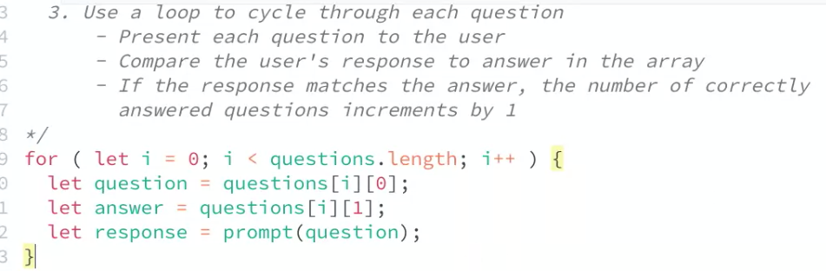

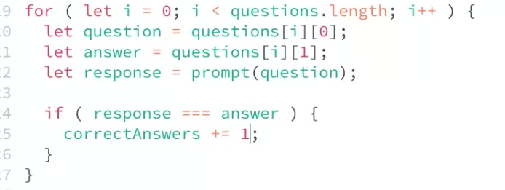

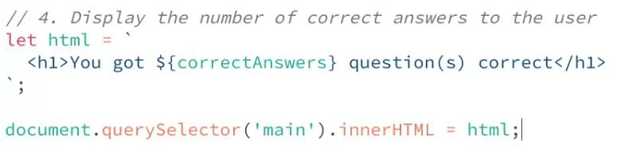

**JAVASCRIPT OBJECTS**

* Obtain properties and methods: A property is like a variable that belongs to the object, and a method is something the object can "do," or that can be "done" to the object. An array is an object
  + Object literals: <https://developer.mozilla.org/en-US/docs/Web/JavaScript/Guide/Grammar_and_types#object_literals>

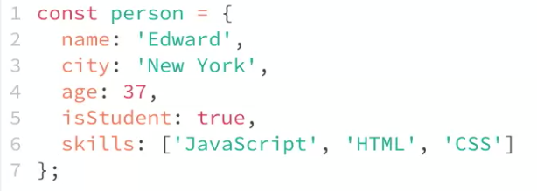

* + - Accessing info in an object:



* + - Changing info in an object and adding new info into an object

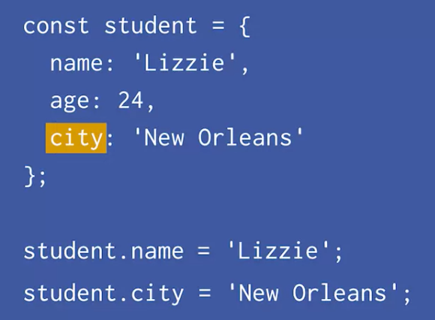 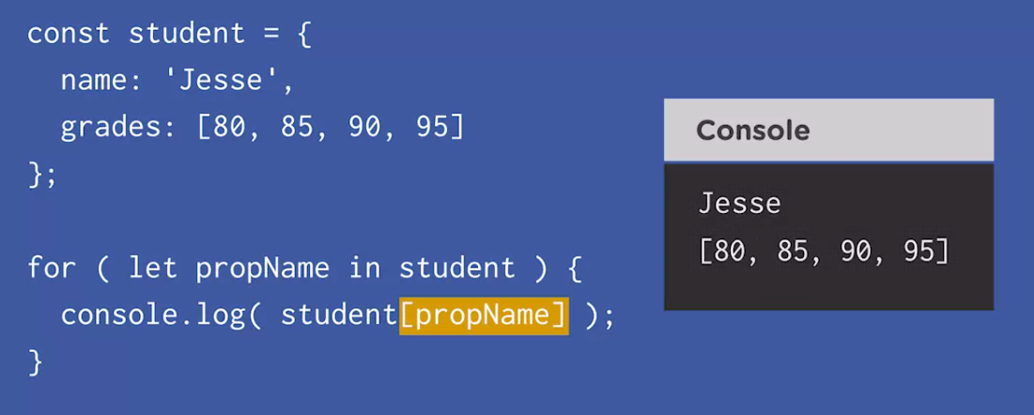

* + - Accessing a property value and displaying all the values in the console

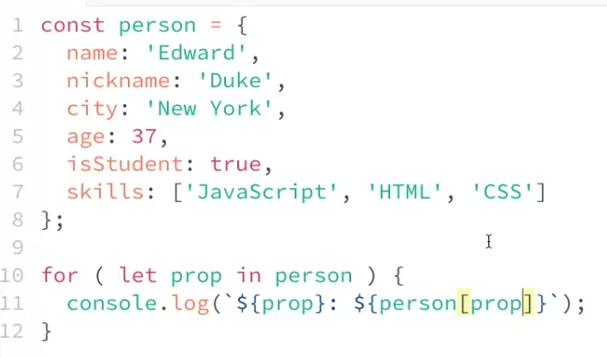

* + - Creating object literals inside an array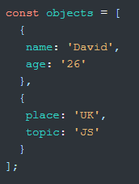

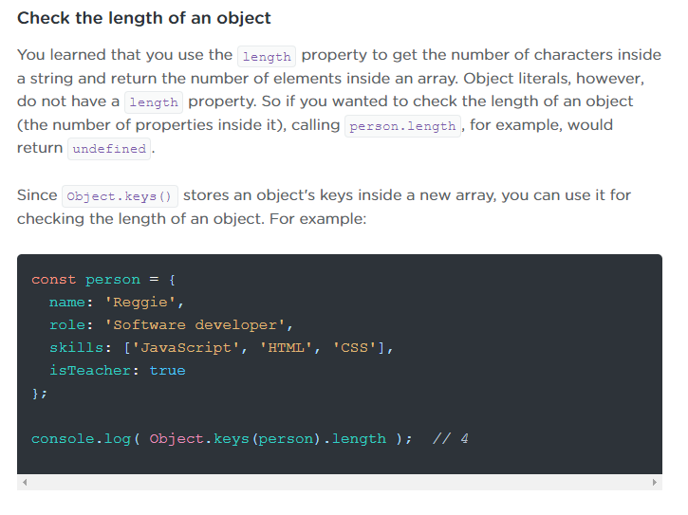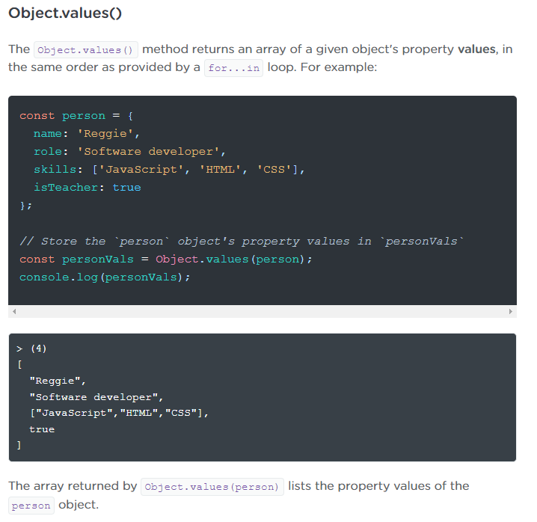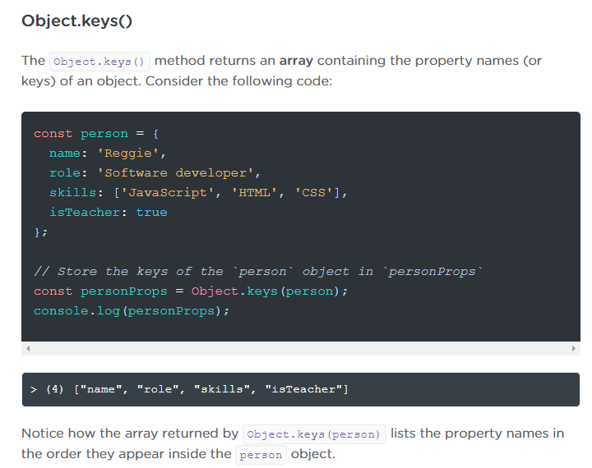

­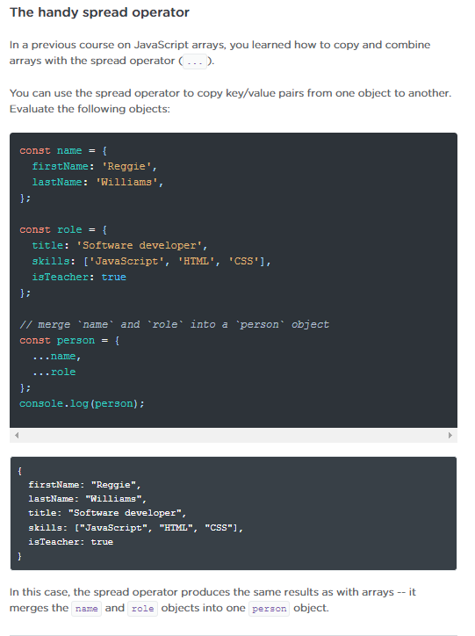

* DOM – document object model
  + <https://developer.mozilla.org/en-US/docs/Web/API/Document_Object_Model>
  + Object-based representation of a web page that JavaScript can use to access and change different parts of the web
  + Interactivity with javascript involves selecting elements, manipulating elements and listening for user actions
  + In the Elements panel, you might see things like pseudo-elements that come from your CSS (::before and ::after). These are [not considered part of the actual DOM](https://dev.to/finallynero/understanding-css-before-and-after-pseudo-elements-ml0), which is one reason why the Elements panel isn't exactly a 1:1 mapping of the DOM tree.

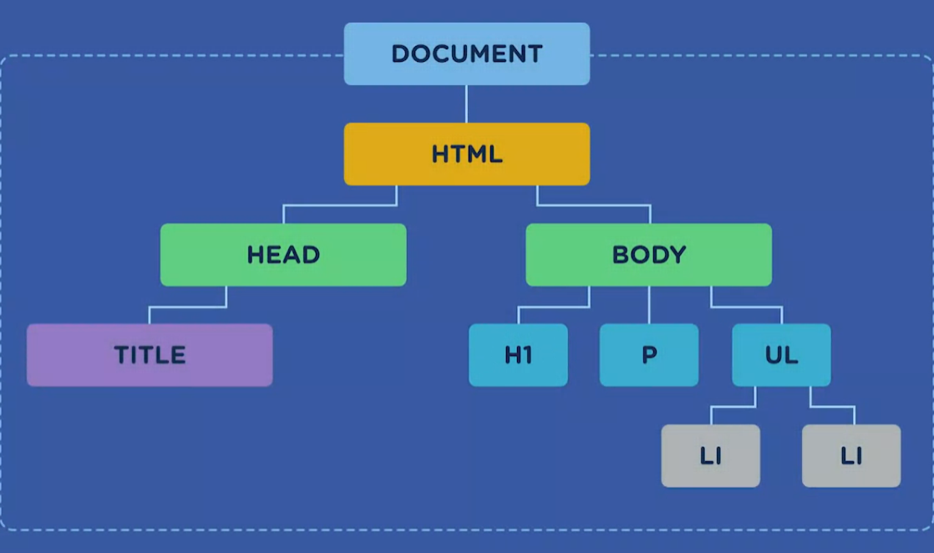

* + Browsers Global window object
    - The browser as a global environment provides variables, objects, and functions additional to those in the core JavaScript language to make things happen inside the browser window; it's what allows your JavaScript code to connect to the DOM and manipulate a web page. The browser has a global object called *window* containing all the properties and methods available to the current browser window.
      * <https://developer.mozilla.org/en-US/docs/Web/API/Window>
      * window is the global object of the environment javascript is running in. so it properties and methods are automatically available even without referencing the window object specifically
    - window.alert()
      * <https://developer.mozilla.org/en-US/docs/Web/API/Window/alert>
    - window.location()
      * <https://developer.mozilla.org/en-US/docs/Web/API/Window/location>

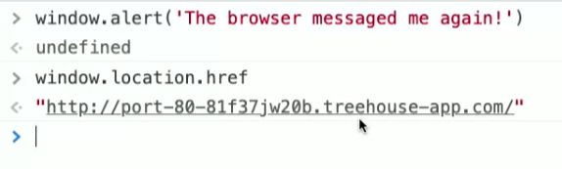

* The window object contains a property named document, which is an object, and it's the entry point into the DOM loaded in the current window. We use the document object to select and control elements of the web page. This document object and some of its common properties are what we'll focus on for the rest of this course.
  + <https://developer.mozilla.org/en-US/docs/Web/API/Document>

Accessing the HTML using the document object, and you can even change css properties using the doc object- this isn’t a normal practice

* Style property names with two or more words, like backgroundColor and borderColor are in [camelCase](https://en.wikipedia.org/wiki/Camel_case). This is different from how you'd write them in CSS with dashes between each word.
* JavaScript's core methods and properties all use camelCase, including all DOM properties, attributes, and event handlers. The inline CSS style declaration properties are no different, and it's important to remember when working with the style property.

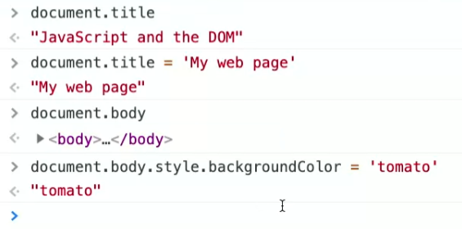

* Element.remove()
  + <https://developer.mozilla.org/en-US/docs/Web/API/Element/remove>
  + removes an element from the DOM

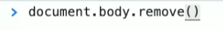

*Intro to Events*

<https://developer.mozilla.org/en-US/docs/Learn/JavaScript/Building_blocks/Events>

* addEventListener()
  + <https://developer.mozilla.org/en-US/docs/Web/API/EventTarget/addEventListener>
  + a method that send a signal to the browser that something has happened within the specified target
  + two arguments (event type to listen to as a string, function that preforms an action in response to the even)

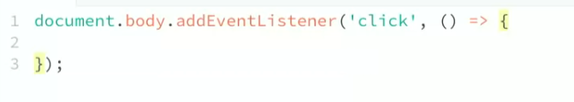

Instructs the function to manipulate the body element and add only an <h1> tag when the body of the web page is clicked

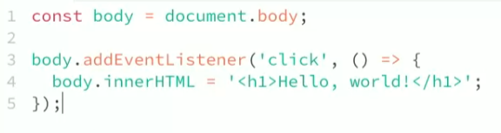

* document.getElementById()
  + <https://developer.mozilla.org/en-US/docs/Web/API/Document/getElementById>
* EventTarget.addEventListener()
  + <https://developer.mozilla.org/en-US/docs/Web/API/EventTarget/addEventListener>

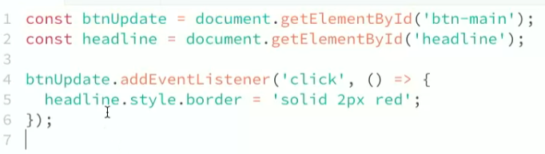

* Document.getElementsByTagName()
  + <https://developer.mozilla.org/en-US/docs/Web/API/Document/getElementsByTagName>
* HTMLCollection & HRMLCollection.length
  + <https://developer.mozilla.org/en-US/docs/Web/API/HTMLCollection>
  + <https://developer.mozilla.org/en-US/docs/Web/API/HTMLCollection/length>
* Loop through an HTMLCollection
  + <https://dev.to/isabelxklee/how-to-loop-through-an-htmlcollection-379k>

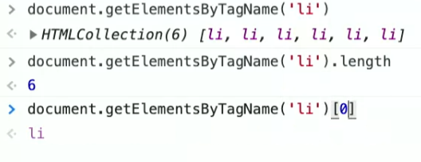

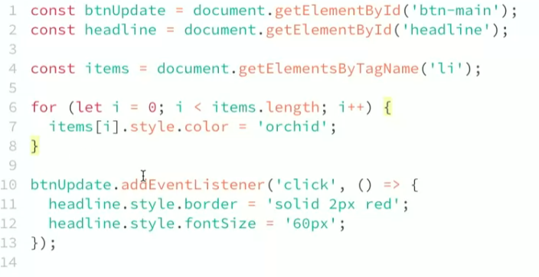

* getElementsByClassName()
  + <https://developer.mozilla.org/en-US/docs/Web/API/Document/getElementsByClassName>

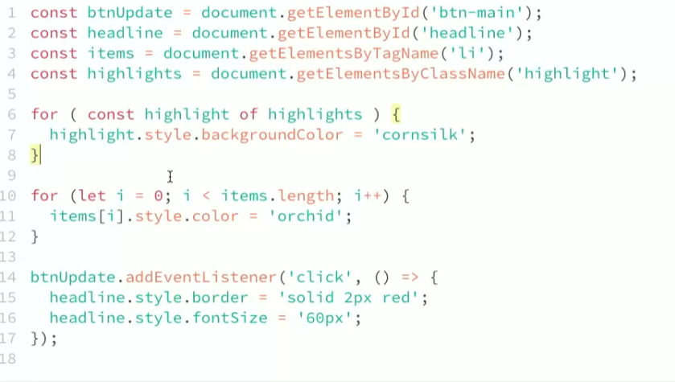

* querySelector()
  + <https://developer.mozilla.org/en-US/docs/Web/API/Document/querySelector>

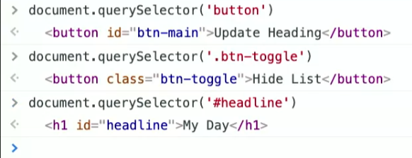

* querySelectorAll()
  + <https://developer.mozilla.org/en-US/docs/Web/API/Document/querySelectorAll>

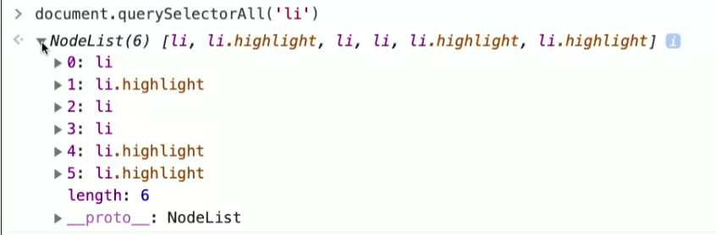

* Node list is more flexible than an HTMLCollection
  + Node lists contain element nodes and text nodes
  + Can iterate over node lists with for, for..of, map(), and forEach()
  + An HTMLCollection only contain elements
  + You cant loop over an HTMLCollection exactly like you would an array
  + HTMLCollection is a live data structure and Node List is a static data structure
    - When a new element gets appended to the DOM, an HTMLCollection will recognize the new element while a Node List will not

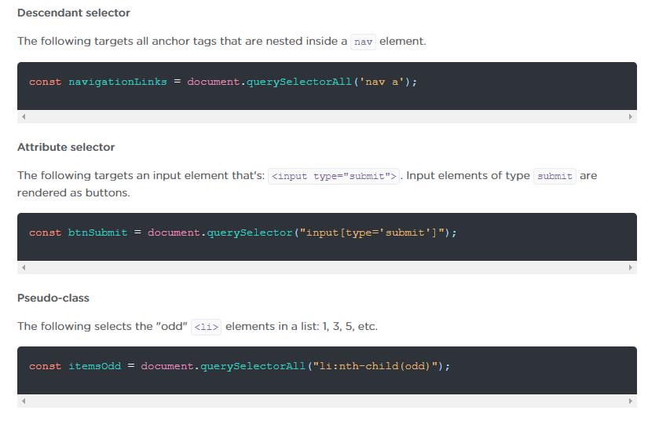

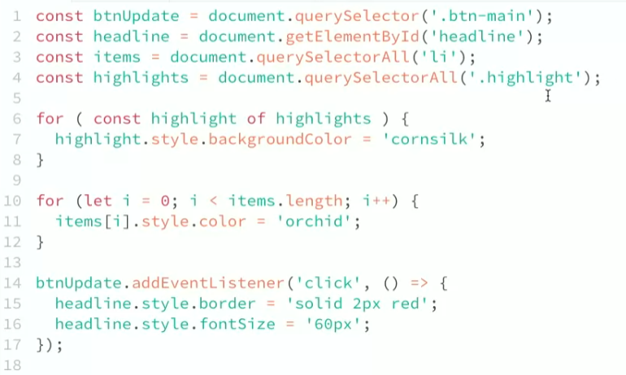



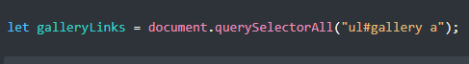

* Get and Set Content with textContent and innterHTML
  + <https://developer.mozilla.org/en-US/docs/Web/API/Node/textContent>
  + <https://developer.mozilla.org/en-US/docs/Web/API/Element/innerHTML>
  + HTMLDataElement: value property
    - <https://developer.mozilla.org/en-US/docs/Web/API/HTMLDataElement/value>

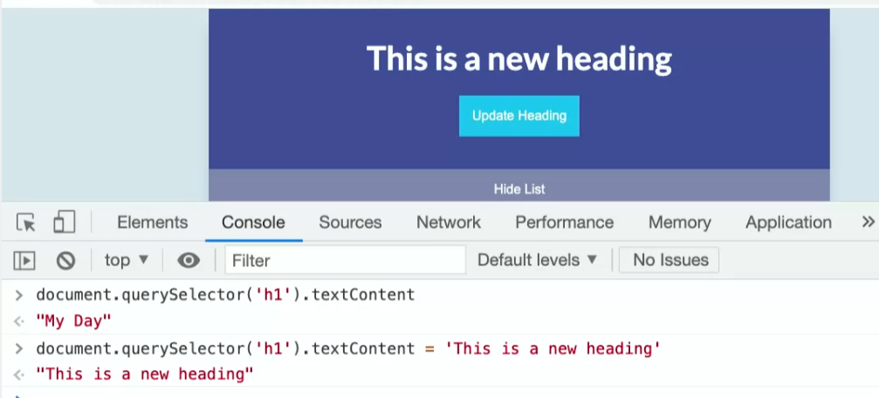

// takes input from a text area and when the button is clicked, the heading is updated and the text area cleared

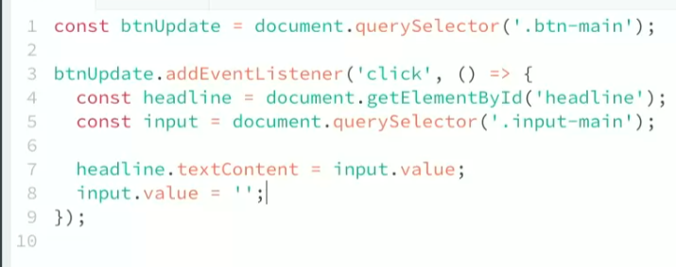

* + HTML tags are converted into objects (called nodes) and placed into the DOM. Attributes exist as properties of element objects, like the href attribute of an <a> element or the action attribute of a <form> element. You get or set those attributes by way of properties, similar to the way you did earlier with an input element's value property and a heading's textContent property.

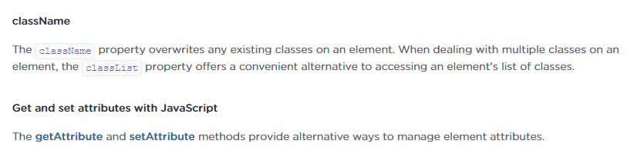

* + - * <https://developer.mozilla.org/en-US/docs/Web/API/Element/getAttribute>
      * <https://developer.mozilla.org/en-US/docs/Web/API/Element/setAttribute>

//changes a heading and the text gets larger

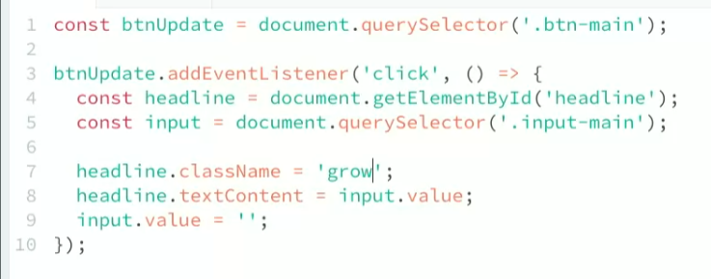

* removeAttribute()
  + <https://developer.mozilla.org/en-US/docs/Web/API/Element/removeAttribute>
* HTMLElement.style property
  + <https://developer.mozilla.org/en-US/docs/Web/API/HTMLElement/style>

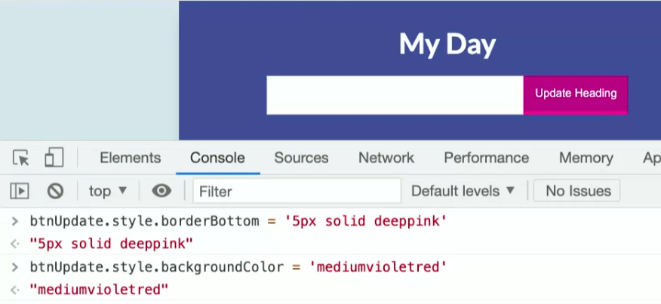

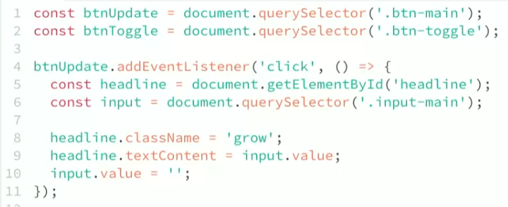

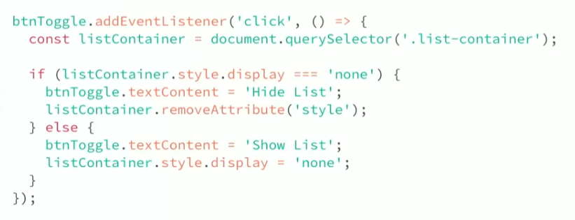

* document.createElement()
  + <https://developer.mozilla.org/en-US/docs/Web/API/Document/createElement>
* Element:append()
  + <https://developer.mozilla.org/en-US/docs/Web/API/Element/append>
  + inserts a new node inside a parent node. Once you use the createElement() method, you can use append() to add it to them DOM
* Element:prepend()
  + <https://developer.mozilla.org/en-US/docs/Web/API/Element/prepend>
* insertAdjacentHTML()
  + <https://developer.mozilla.org/en-US/docs/Web/API/Element/insertAdjacentHTML>
  + This method provides more control over inserting HTML inside a parent. You pass it the HTML and text content to create as a string, and then that string gets parsed and inserted into the DOM at the position you specify.

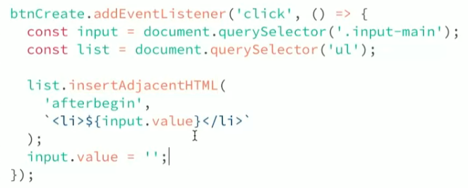

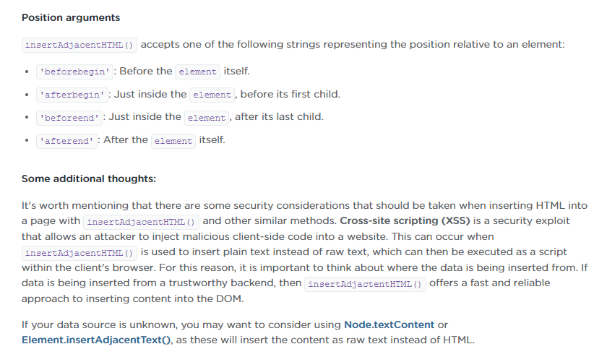

* Element.remove()
  + <https://developer.mozilla.org/en-US/docs/Web/API/Element/remove>

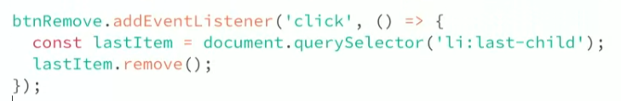

**Interacting with the DOM**

* Functions are often called first-class citizens in JavaScript. This means just like other data types, they can be stored in variables, and most importantly, passed into other functions.
* Once an element is selected, we can use a powerful method called addEventListener to listen for events, then make changes to that element or parts of the web page.

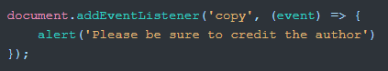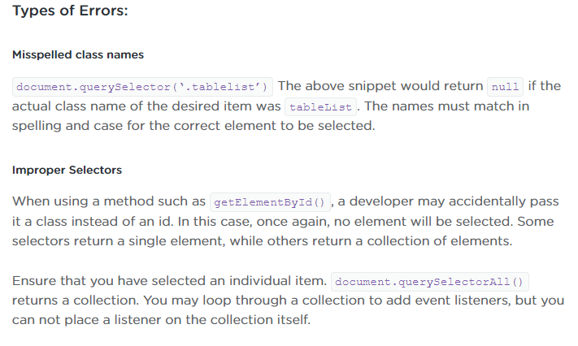

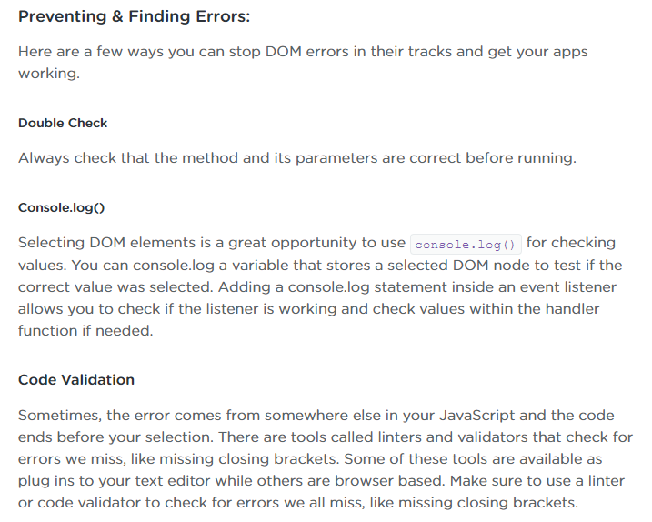

* JavaScript Code Validator
  + <https://beautifytools.com/javascript-validator.php>
* In JavaScript, each event triggers the creation of an event object which tells us all about the event. When an event handler is called, it receives an event object as its first argument. This object also gives us access to a few methods we can use to help us work with the event inside the handler.
* An event received by an element doesn't stop with that one element. That event moves to other elements -- the parent, and other ancestors of the element. This is called bubbling
  + <https://developer.mozilla.org/en-US/docs/Learn/JavaScript/Building_blocks/Events#event_bubbling_and_capture>
  + <https://javascript.info/bubbling-and-capturing>
* Event delegation is a handling pattern. It’s the idea that a single handle is put on a common ancestor
  + <https://javascript.info/event-delegation>





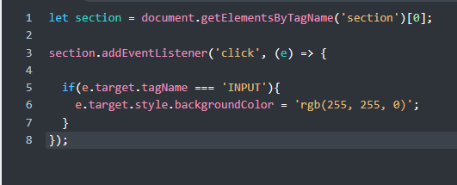

* Parent node
  + <https://developer.mozilla.org/en-US/docs/Web/API/Node/parentNode>

**Object- Oriented JavaScript**

* An object is a neat and tidy packages of information about something you want to use in your code, this packages contains a group of properties and functions that work to together to represent something in your program
  + An objects properties are a series of key values pairs that hold information about the object and its functions are called methods
  + Methods let your object do something or lets something be done to it
  + Objects have states and behaviors
    - States are represented by an objects properties
    - Behaviors are represented by an objects methods
  + {} curly braces are how we notate an object
    - {} are different than []
  + Encapsulation describes consolidating an object’s properties and methods into a package and attaching it to a variable
  + Key is the name of the property and the value of the property follows after the colon, each new method and property are usually separated by commas

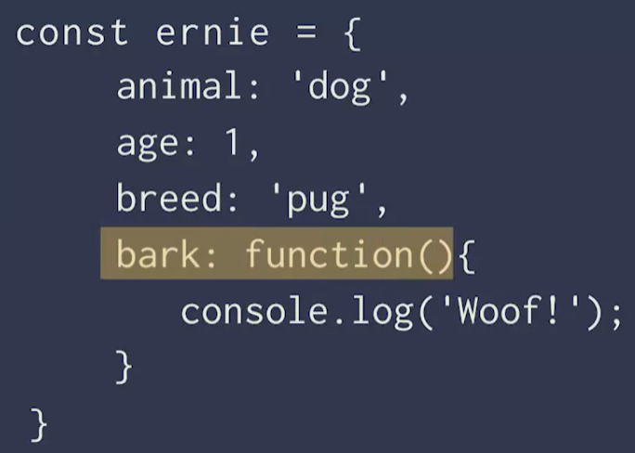

* + Bracket Notation

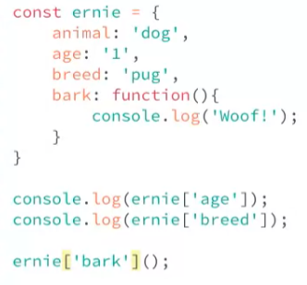

* + Dot Notation

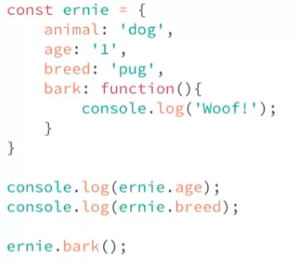

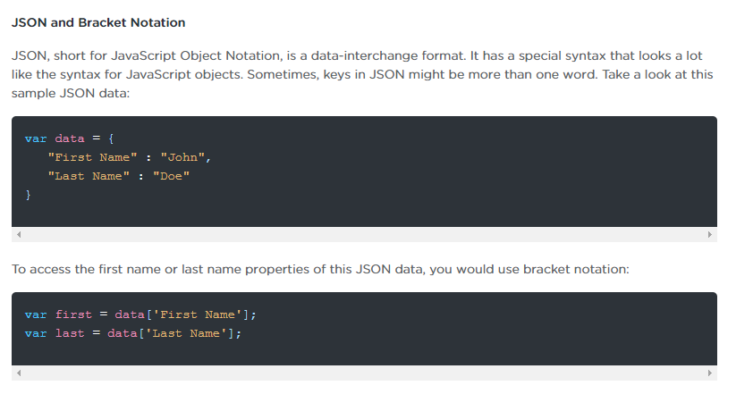

* + Changing a value in an object literal using dot & bracket notation

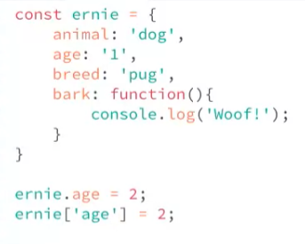

* + Adding a key to an object literal

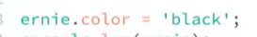

* Class Syntax:
  + - <https://developer.mozilla.org/en-US/docs/Web/JavaScript/Reference/Classes>
  + A constructor method is placed at the top of a class and it outlines the properties that your class will have
    - <https://developer.mozilla.org/en-US/docs/Web/JavaScript/Reference/Classes/constructor>
  + The “this” keyword means many different things which is determined by how a function is being called.
    - <https://developer.mozilla.org/en-US/docs/Web/JavaScript/Reference/Operators/this>

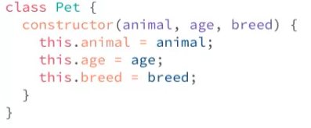

* + - Instantiating an Object using a ^Class

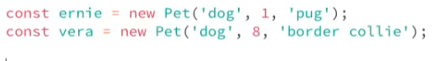

* + When ready to console log an object, just console log the name of the variable used to create the object



* + Adding methods to a class

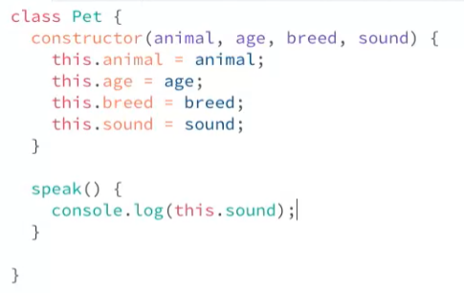

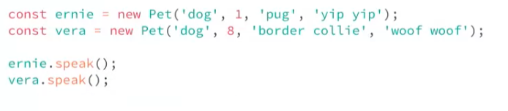

* Getter and Setter Methods (<https://developer.mozilla.org/en-US/docs/Web/JavaScript/Guide/Working_with_Objects#defining_getters_and_setters>)
  + A getter method is used when you want to have a property that has a dynamic or computed value. The value of the property is computed in the getter method. Even though its not stored or attached to the object, it can be accessed just like a regular property
    - When called as a function, returns a string representation of the current date and time. <https://developer.mozilla.org/en-US/docs/Web/JavaScript/Reference/Global_Objects/Date>

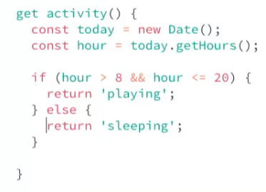

* + A setter method receives a value and can preform logic on that value if need be. Then it either updates an existing property with that value or stores the value to a new property.
    - The name of a property can never be the same as a getter or setter method.
      * The property name must be different than the setter or getter method names. This is called a backing property.
        + While the backing property name can be whatever we want, convention dictates to use the name of the setter function but with an underscore behind it

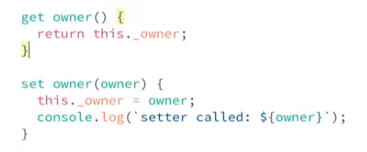

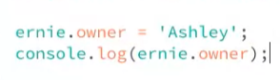

* Object Interaction
  + The value of an object property can be another object.
  + OOP is a programming paradigm that uses objects. These objects are deigned to interact with each other.
  + Regular Expressions
    - <https://developer.mozilla.org/en-US/docs/Web/JavaScript/Guide/Regular_Expressions>

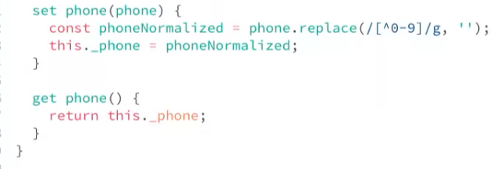

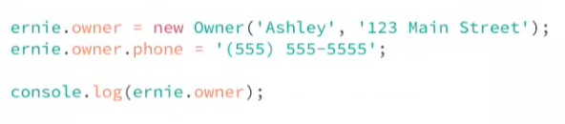

**AJAX**

* Asynchronous JavaScript and XML
* Lets you update content on a web page without loading a new web page
* AJAX can be used with ruby, python, PHP, and cold fusion
* When a server answers an AJAX request it sends back a response
* XMLHttpRequest - <https://developer.mozilla.org/en-US/docs/Web/API/XMLHttpRequest>
  + XHR objects are used to interact with servers
* How AJAX Works
  + Create a XHR request
    - When adding AJAX requests to your pages, you need to view that page through a web server in order to preview the results
  + Create a callback function
    - Callbacks for multiple AJAX requests may not run in the order the requests were sent
  + Open a request
  + Send the request

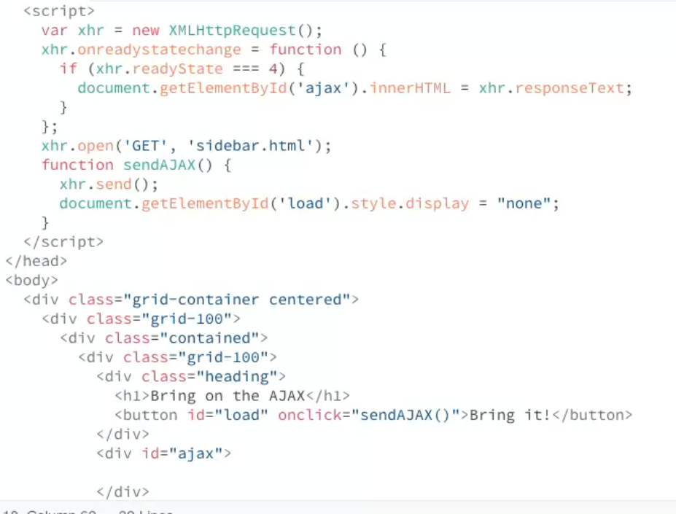

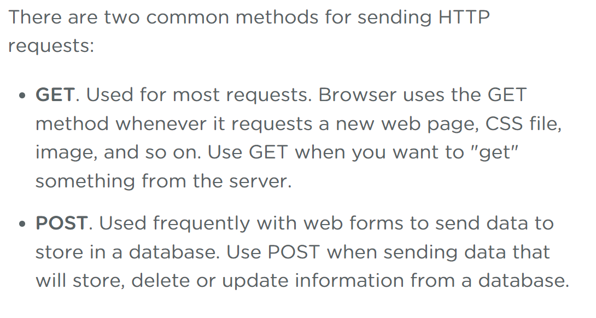

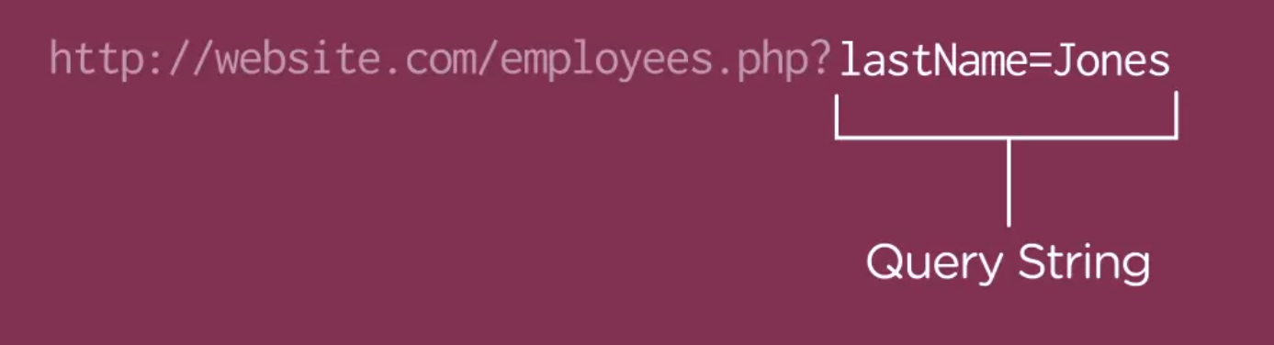

* A query string shows at the end of a web link and provides a way to send additional info that a web server can use to control the output of its response. Commonly the data in a query string is used to search a database of info and return just a single record or a small subset of information
* URL encoded strings - <https://www.url-encode-decode.com/>

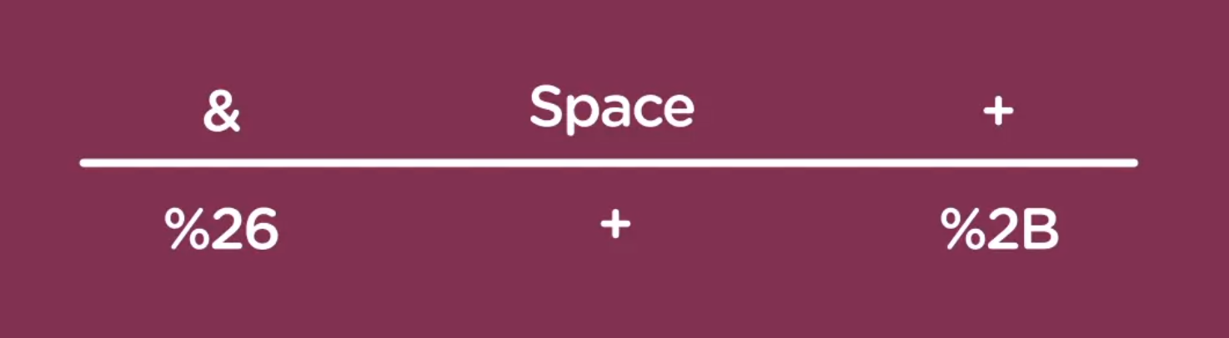

* XML stand for Extensible Markup Language

Parsing

* <https://developer.mozilla.org/en-US/docs/Web/Guide/Parsing_and_serializing_XML>
* <https://api.jquery.com/jQuery.parseXML/>

AJAX Security Limitations

* Web browsers prevent certain types of AJAX requests, such as requests to other websites. Learn the rules of a web browser's "same-origin" policy and ways to work around these limitations.
  + <https://developer.mozilla.org/en-US/docs/Web/Security/Same-origin_policy>

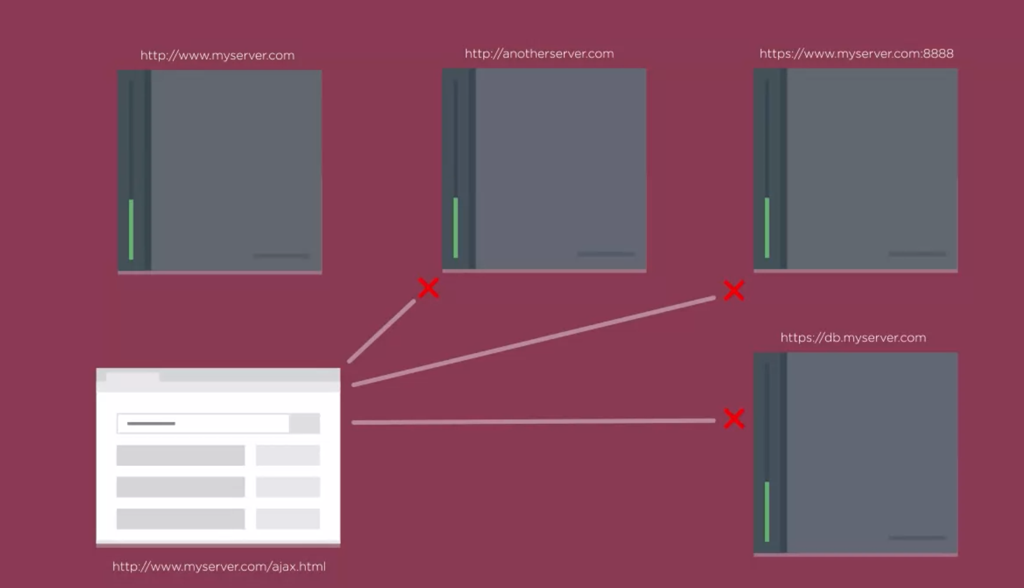

* + <https://developer.mozilla.org/en-US/docs/Web/HTTP/CORS>
* Web Proxy asks for information from another website
  + Allows you to bypass a web browsers same-origin policy by retrieving data from another server, while keeping AJAX requests within the same domain

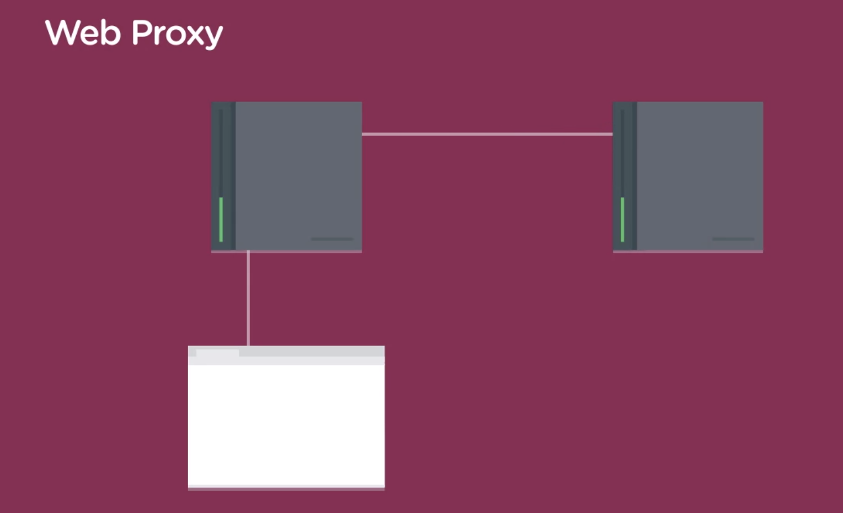

* JSONP – JSON with Padding (not traditional AJAX)
  + Relies one the ability to link to js files across domains. Browsers do allow many types of cross domain links
* CDN – Content Delivery Network
  + They host files that other website can use – like jquery

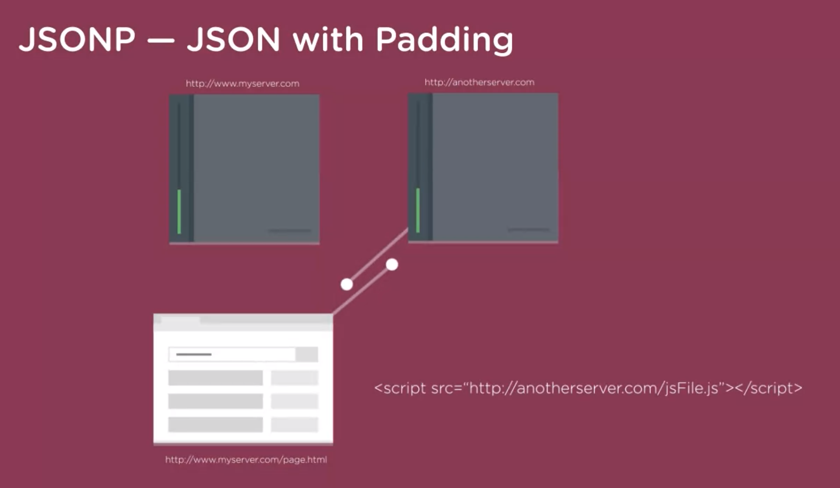

* CORS – Cross origin resource sharing
  + Requires some set up on the server part
  + W3C recommendation

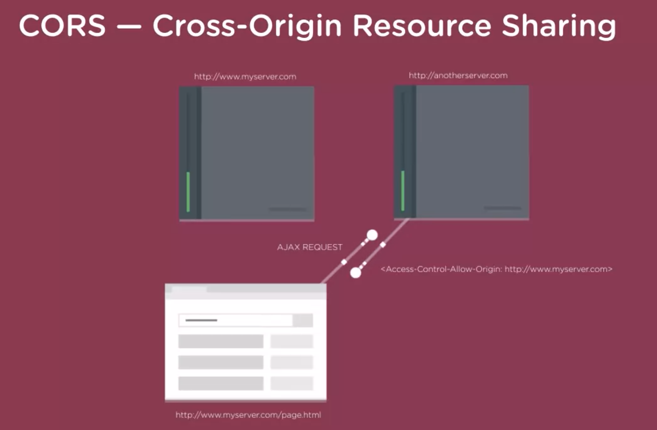

* Intranet – an internal website that only the people that work for a company can use

AJAX Callbacks

* HTTP Status code of 200 means OK
* HTTP Status code of 404 means file not found
* The value of an XMLHttpRequest objects ready state when the browser has received all data from the server is 4

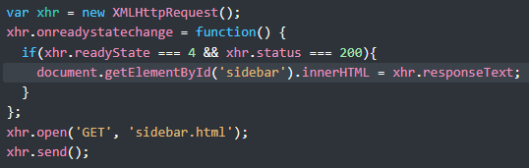

Page that doesn’t exist, js to catch the error

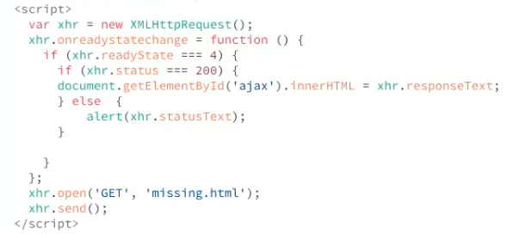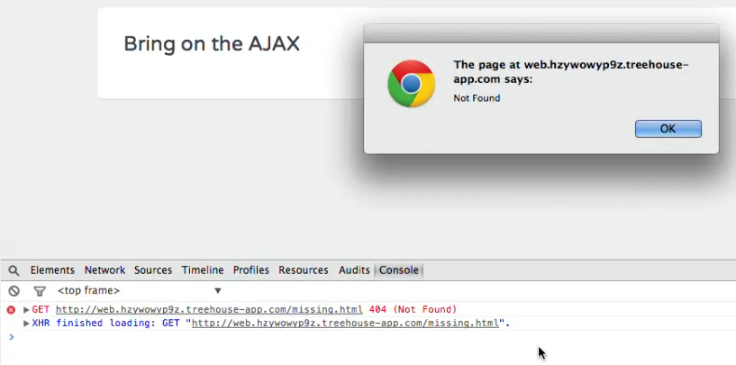

JSON – JavaScript Object Notation

* + JSON Validator <https://jsonlint.com/>
* JSON can be formatted using an array notation or an object notation
  + - Common to combine both
  + An object is a set of key value pairs (property value pairs). A key is a name used to identify a property, value is the value you want to give that property. Every key and value pair is separated by a colon, and every value is separated by a comma
    - In JSON double quotes are required to be used with key value pairs with objects, except for Boolean values

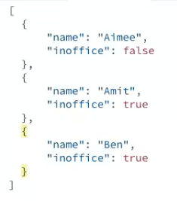

* JSON is transmitted over the web as plain text. To make it useful for a JavaScript program, you need to parse it, or convert it from a string to JavaScript.
  + JSON.parse(); - <https://developer.mozilla.org/en-US/docs/Web/JavaScript/Reference/Global_Objects/JSON/parse>
    - Will not work if json is not formatted correctly

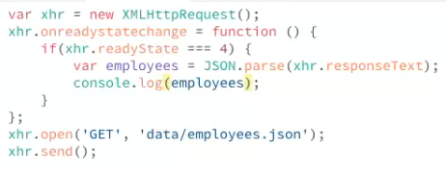

* Processing JSON Data
  + Create a new HTML list item
  + Check the property
  + Get the value for the property and insert it inside the html list item
  + Close the html list

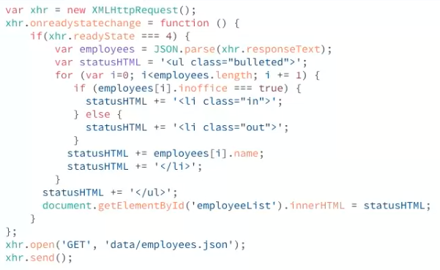

**Synchronous & Asynchronous JavaScript**

* Synchronous programming completes one task at a time, and other parts of the program are blocked until a task is completed. Asynchronous programming completes multiple tasks at a time and not letting one task get in the way of another task
* Call Stack
  + Keeps Track of the order of function calls and where it is in a program at any given moment.
  + Anytime a function gets called, it gets **pushed** onto the call stack, and any functions called within the original function are pushed higher up onto the call stack. When a function is done executing, it gets **popped** off the top of the call stack, and the next function in the stack gets processed.
    - When the stack finished executing, the program is finished leaving the stack empty

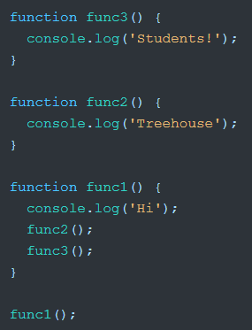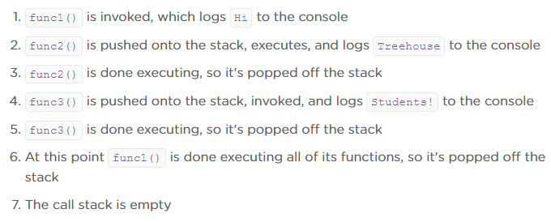

* **The call stack handles asynchronous tasks in a different way than synchronous tasks**. Whenever the JavaScript environment encounters code that needs to run and execute at a later time, like a setTimeout() callback or a network request, that code is handed off to a special Web API that processes the async operation. Meanwhile, the call stack moves on to other tasks and then revisits the async task when it's ready to be dealt with.
* It's important to note that **the asynchronous behavior of JavaScript does not come from the JavaScript engine itself**. JavaScript engines like Chrome's V8, for instance, do not have asynchronous capabilities. Asynchronicity actually comes from the runtime environment. Runtime environments (like web browsers and Node) provide APIs that let JavaScript run tasks asynchronously.

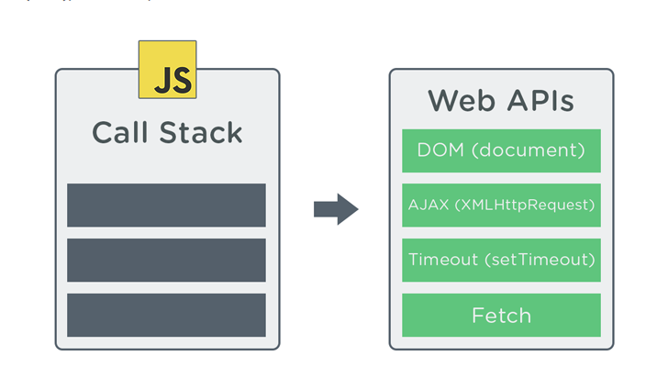

* When a web API is done processing an async task, it's not immediately executed on the call stack. Instead, its associated callback function gets pushed into something called the **callback queue**, which is a list (or line) containing all the async task callbacks waiting to be executed.
  + A callback queue is like a holding area for all the callbacks that are waiting to be put on the call stack and eventually executed.
  + The web APIs add each async tasks to the callback queue where they wait to be pushed onto the call stack one at a time.
  + The event loop monitors the call stack and the callback queue and anything the call stack is empty, the loop takes the first task from the callback queue and pushes it onto the call stack and runs it

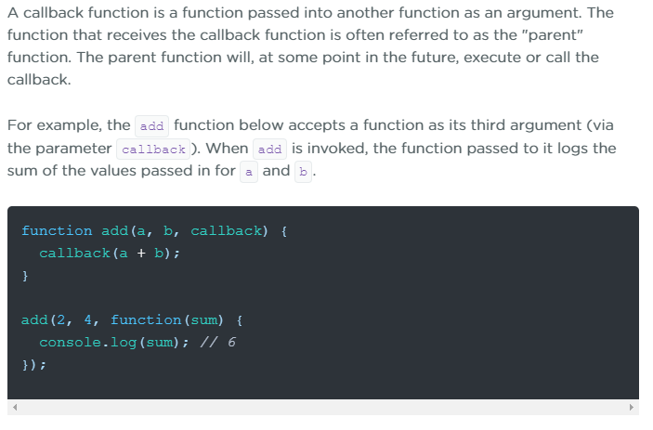

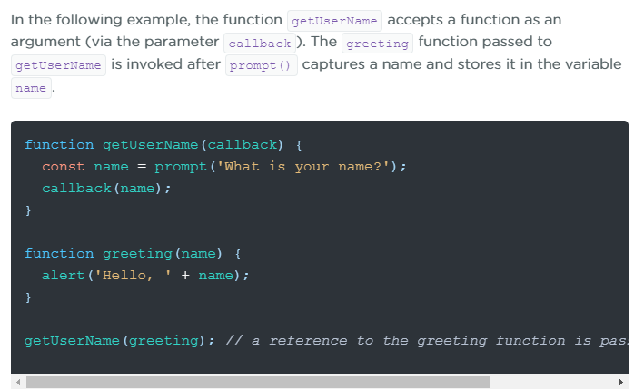

* Continuation-passing style (CPS)
  + Create a chain of function calls, where one tasks runs after another is completed

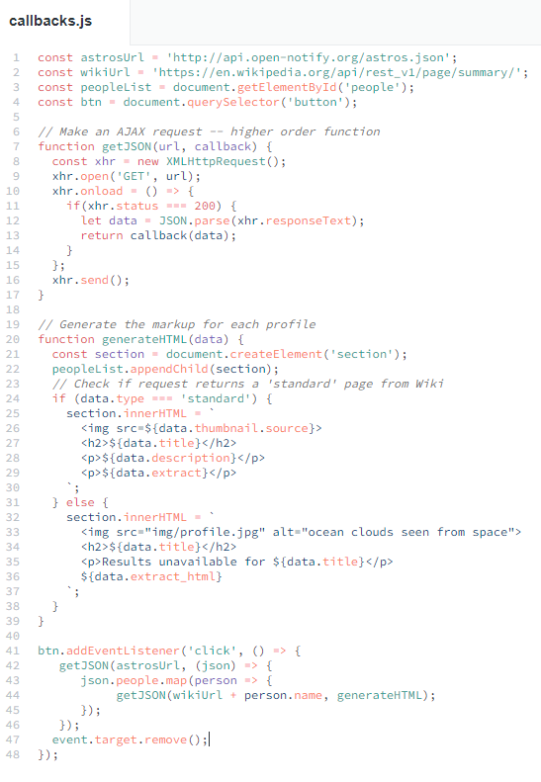

* Each callback adds a level of nesting, the code may get complicated quickly. To make this easier, you can break up the callbacks into separate functions and just call them in the nested callback

**PROMISES**

* What is a promise?
  + Eventual completion of an async operation. Straightforward alt for composing and managing async code without having to write too many callback or spend extra time figuring out what the program should do. They guarantee a future value and nothing can change regardless of whether or not it is fulfilled or rejected.
    - A JS object that changes pending state to either fulfilled or rejected state.
  + <https://medium.com/javascript-scene/master-the-javascript-interview-what-is-a-promise-27fc71e77261>
* Working with promises:
  + Create a promise instance using the Promise() constructor
  + Define what should happen when the promise is fulfilled or rejected.
  + Consume the value of a fulfilled promise or provide a rejection reason for the rejected promise
    - Should always specify a catch on a promise to avoid the promise from silently failing

Resolved promise .then() :

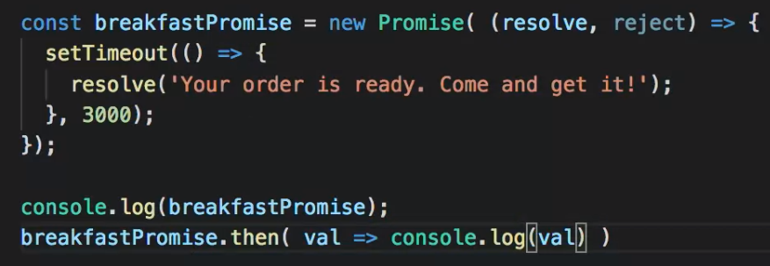

Rejected promise .catch() :

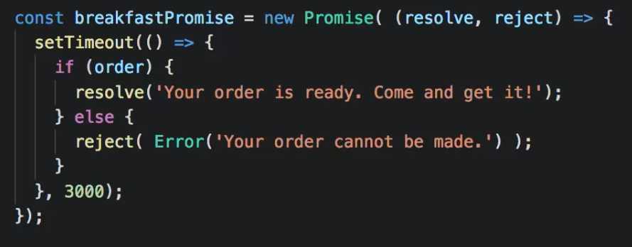

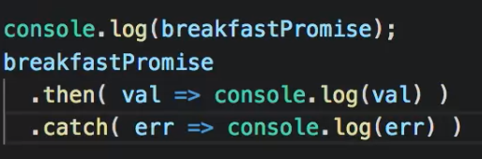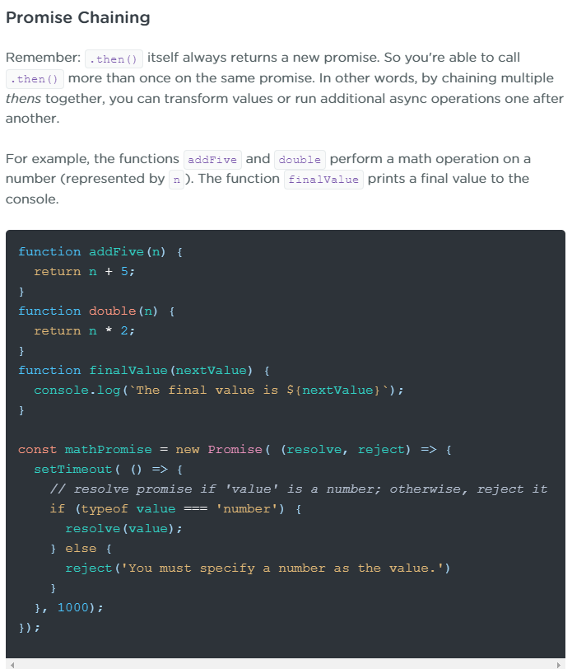

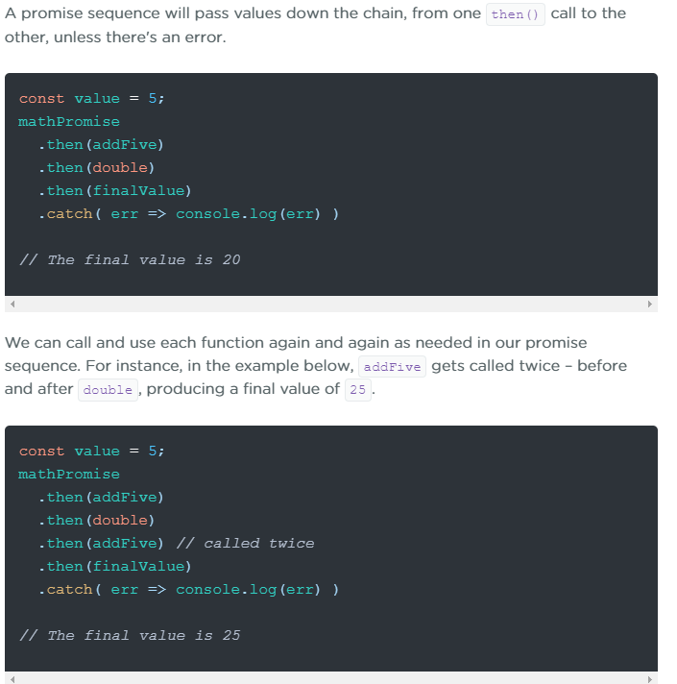

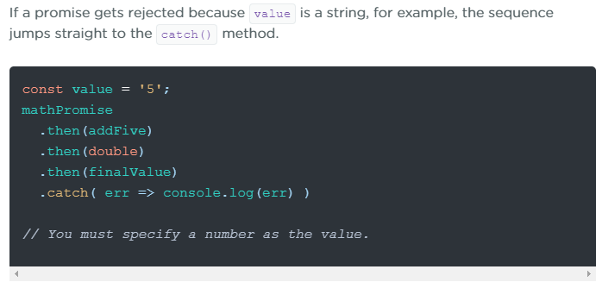

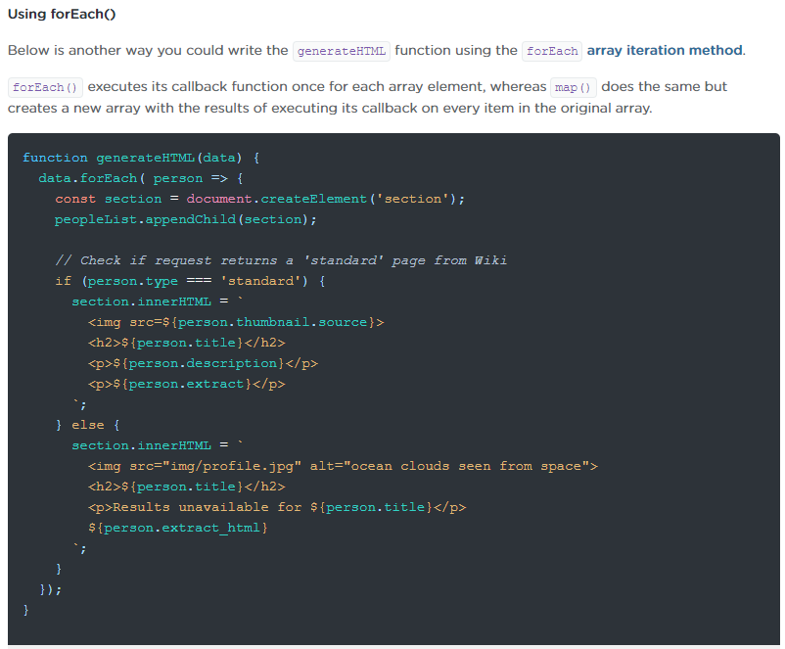

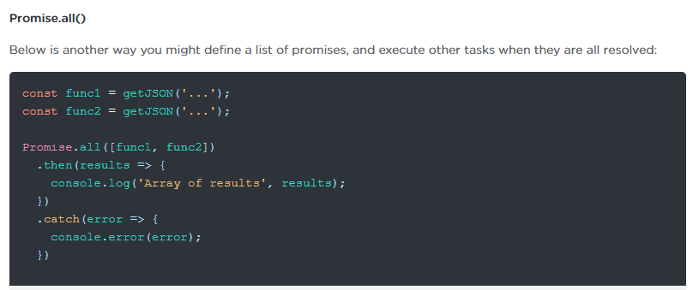

Using Promise.all()

* All or nothing method, if the first promise rejects, then all of them do

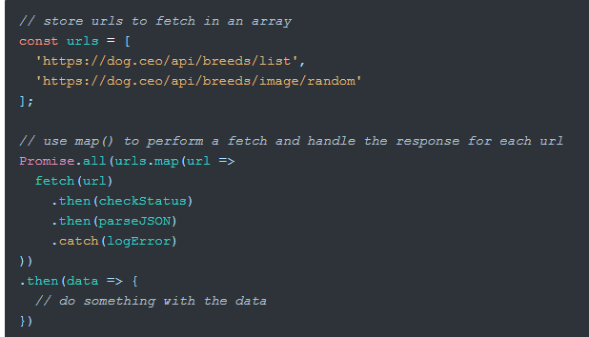

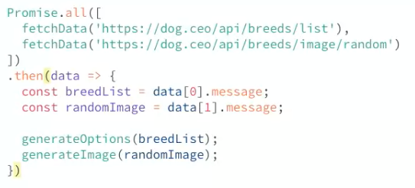

* Finally()
  + When this method gets called, once a promise is fully settles, regardless of whether it is fulfilled or rejected. It is useful when you need to do some cleanup after the promise sequence is finished
  + <https://developer.mozilla.org/en-US/docs/Web/JavaScript/Reference/Global_Objects/Promise/finally>

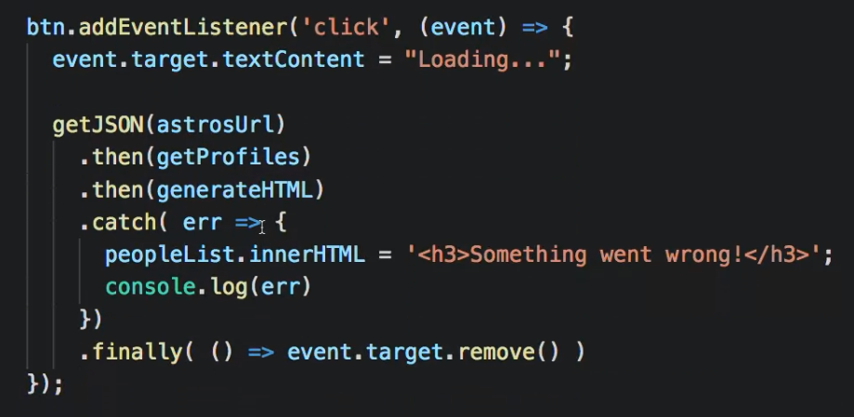

* Async/await- special tax to work with promises in a way that feels more intuitive and concise
  + Its async code that resembles synchronous code
  + Async/await is syntactic sugar for creating functions that return and wait for promises, it’s a supplement to promises

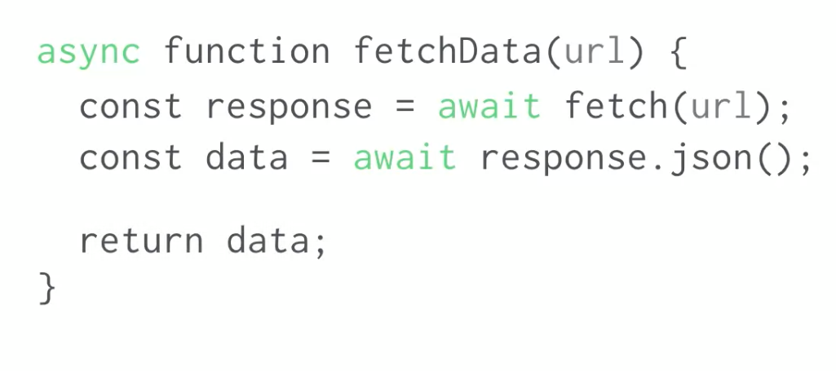

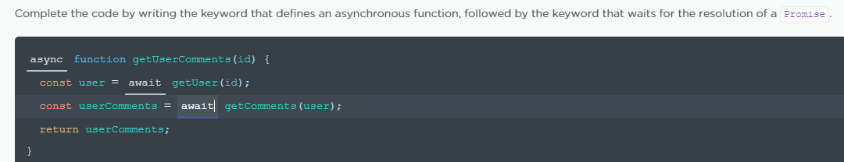

* Await - <https://developer.mozilla.org/en-US/docs/Web/JavaScript/Reference/Operators/await>
  + Pauses the execution of an async function and waits for the resolution of a promise
  + Resumes execution and returns the resolves value
  + Pausing execution is not going to cause blocking behavior
  + Valid only inside functions marked async

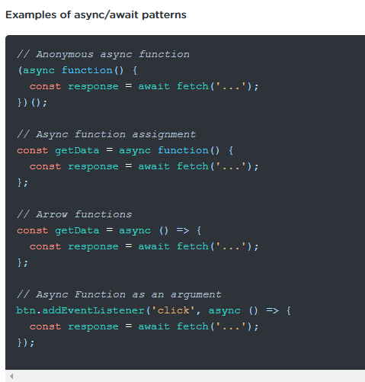

* <https://developer.mozilla.org/en-US/docs/Web/JavaScript/Reference/Statements/try...catch>
  + Most common way to handle exceptions when using async/await

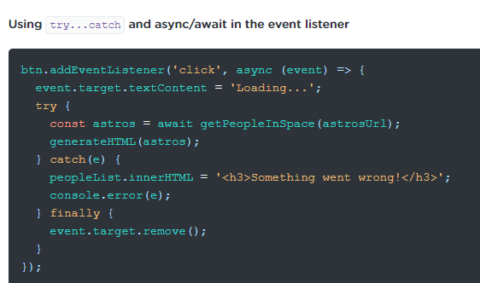

* Fetch API – powerful and flexible replacement for XMLHttpRequest
  + <https://developer.mozilla.org/en-US/docs/Web/API/Fetch_API>

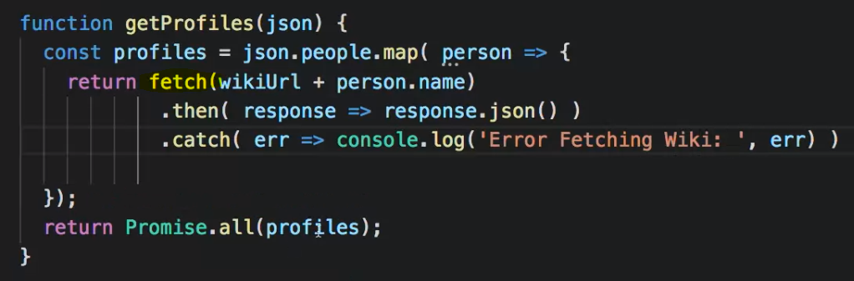

Using the fetch method to insert an image into the html page using json to parse the data:

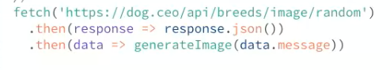

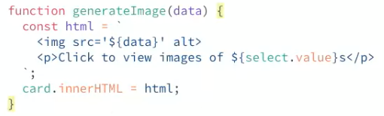

Using the fetch method to insert options into a dropdown menu into the html page using json to parse the data:

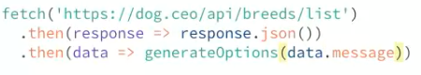

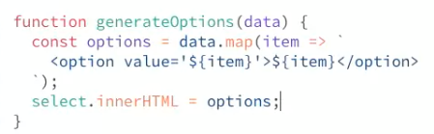

Checking for errors:

